# Role of the poliovirus laboratory

Laboratory testing of stool specimens from AFP cases or healthy contacts, and of environmental samples, is the most important surveillance component required to set up surveillance that is sufficiently sensitive for poliovirus detection in the polio eradication program. While the laboratory component is critically important, making best use of lab results will depend on effective collaboration between clinicians, epidemiologists, immunization programs and polio laboratories at the national, regional and the global levels.

## African Regional and Global Polio Laboratory Networks

The WHO Regional and Global Polio Laboratory Networks (GPLN) were established by WHO to ensure that high-quality diagnostic services are available to polio programs in all countries. At the global level, over 220 000 stool samples from AFP cases and their contacts and more than 12 000 sewage samples are processed every year. In 2022, 87483 stool samples from AFP cases and their contacts and 8978 sewage samples were processed by the African Regional Polio Laboratory Network. These figures have been rising since 2020 due mainly to increasing outbreaks of cVDPVs and extension of environmental surveillance in the region.

As of 2022, the global network consists of 146 WHO-accredited polio laboratories in 92 countries across six WHO regions (Fig. 9). Of these, 123 are national or subnational level laboratories, 17 are regional reference laboratories, and 6 are global specialized laboratories. The African polio network consists of 16 polio laboratories (NPLs), across 15 countries. Of these, 13 are national level labs and three are regional reference laboratories.

To be included in the network, laboratories must have the proven capability and capacity to reliably and timely detect, identify and promptly report WPVs and VDPVs that may be present in clinical and environmental specimens. Likewise, the program must be able to rely on negative results from a laboratory, i.e. 'no virus isolated', as evidence that an area or country is polio-free.

Accreditation by WHO means that the polio laboratories conform to common standards, or codes of practice, of the WHO GPLN, for detecting and characterizing polioviruses from stool specimens and sewage samples. The accuracy and quality of testing of each lab is monitored by WHO through an annual accreditation program that includes onsite reviews of infrastructure, equipment, standard operating procedures (SOPs), work practices, and performance, as well as external proficiency testing.

Depending on their degree of specialization, roles of global polio network laboratories include to:

* + - detect poliovirus from stool specimens and sewage samples by isolation, using cell culture;
    - identify and differentiate wild from vaccine or vaccine-derived polioviruses, using intratypic differentiation (ITD);
    - genetically characterize polioviruses, using sequencing methods, which also determine whether isolated viruses are wild, vaccine-like or vaccine-derived;
    - rapidly trace the geographic origin of new polioviruses isolated from AFP cases, contacts or from sewage samples, by comparing the genetic sequence of isolated viruses using a reference bank of virus nucleotide sequences.

## Coordination between field and laboratory surveillance

Polio field and laboratory surveillance teams cooperate closely to:

* ensure that the laboratory is notified in advance of the shipment of stool specimens, and that the newly issued AFP case EPID-number is inserted into the lab request form;
* ensure that the laboratory provides feedback on the condition of stool specimens on arrival in the lab, particularly if there is a need to repeat specimen collection;
* ensure laboratories receive timely notice of any field surveillance activities affecting laboratory workload and testing capacity, such as additional sampling of contacts or healthy children, such as during the early phase of a new outbreak;
* regularly share all available data to ensure the accuracy of case details (e.g., EPID numbers), with corrective action taken when there are problems;
* mutually share epidemiological findings, laboratory and genomic sequence results, and final case classification; and
* reduce the period *between the identification of an AFP case and final laboratory results* so new virus-positive cases can be responded to as swiftly as possible. For a more detailed discussion of possible delays between AFP case detection and final laboratory results, please also consult Annex 8.

Key timeliness indicators to monitor in relation to specimen transport and laboratory testing are:

* the duration of specimen transport from the field to the lab: ≥80% of stool specimens should arrive at a WHO-accredited polio laboratory under reverse cold chain conditions within three (3) days of collection of the second stool specimen collection, and
* the time between receipt of specimens in the laboratory and sharing final laboratory results. For at least 80% of case or environmental specimens, this interval should not be longer than 21 days.

## Possible laboratory results

Table 7 shows the possible laboratory results which polio labs may communicate. These include:

* OPV-like, Sabin-like (SL), or nOPV2-like, i.e. the virus isolate is a vaccine-like virus (OPV, or nOPV2)
* WPV - wild poliovirus,
* VDPV - vaccine-derived poliovirus,
* NPEV - non-polio enterovirus, other viruses (non-enteroviruses, or NEV) or
* no virus isolated (NVI).

###### Table 7: Possible polio laboratory results - testing of stool and environmental samples

|  |  |  |
| --- | --- | --- |
| **Lab results** | **Type of virus** | **Reported as** |
| **OPV-like or Sabin-like (SL),**  **or nOPV2-like** | Vaccine strain poliovirus type 1, 2 or 3 | SL1, SL2, SL3, nOPV-like |
| **Wild poliovirus** | Wild poliovirus type 1, 2 or 3 | WPV1, WPV2, and WPV3 |
| **Vaccine-derived poliovirus** | Vaccine-derived poliovirus type 1, 2 or 3, further classified as:   * circulating VDPVs (cVDPVs) * immunodeficiency-associated VDPVs (iVDPVs) * ambiguous VDPV (aVDPV) | VDPV1, VDPV2, VDPV3,  further reported as:   * cVDPV1, cVDPV2, cVDPV3 * iVDPV1, iVDPV2, iVDPV3 * aVDPV1, aVDPV2, aVDPV3 |

|  |  |  |
| --- | --- | --- |
|  | This is done by combining laboratory results with epidemiological and clinical information.  * For nOPV2, specific terminology will be used when sufficient data will be gathered |  |
| **Non-polio enteroviruses** | Non-polio enteroviruses | NPEV or NPENT |
| **Non-enteroviruses** | Non- enteroviruses | NEV |
| **No virus isolated** | No virus isolated | NVI |

aVDPV = ambiguous vaccine-derived poliovirus; cVDPV = circulating vaccine-derived poliovirus (types 1,2,3); iVDPV = immunodeficiency-associated vaccine derived poliovirus (types 1,2,3); NEV = non-enterovirus; nOPV = novel oral polio vaccine; nOPV2 = novel oral polio vaccine type 2; NPENT = non-polio enterovirus; NPEV = non-polio enterovirus; NVI = no virus isolated; OPV = oral polio vaccine; SL = Sabin-like (types 1,2,3); VDPV = vaccine-derived poliovirus (types 1,2,3); WPV = wild poliovirus (types 1,2,3)

## Monitoring laboratory timeliness

The timeliness of the work done in GPLN member laboratories is routinely measured, with the following indicators and their targets for stool specimen processing. Note that the target intervals for lab timeliness which laboratories should reach, differ depending on whether or not the specimen derives from a country which already uses a newly introduced laboratory method called 'direct detection'. Direct detection significantly shortens the time needed until a final lab result is available.

* ≥80% of specimens with final results available within 21 days of receipt from a direct detection country OR within 28 days of receipt from a non-direct detection country at a WHO-accredited polio laboratory.
* ≥80% of specimens with WPV/VDPV final results available within 21 days of receipt from a direct detection country OR within 28 days of receipt from a non-direct detection country at a WHO- accredited polio laboratory.
* ≥80% of poliovirus specimens with sequencing results available within 7 days of receipt of isolate

at a WHO-accredited Polio sequencing laboratory.

The *overall target and indicator for the timeliness of obtaining final laboratory results (interval from paralysis onset to specimen testing and result) for priority countries* is:

* ≥80% of WPVs and VDPVs reporting final laboratory results within 35 days of AFP case onset of paralysis.

# Polio surveillance support functions and logistics

Several important support functions need to be established and well-implemented in order For AFP and poliovirus surveillance to reach the required levels of sensitivity. These functions include:

* **planning** for surveillance activities,
* using **social mobilization** and communication to create awareness among health workers and in communities of the AFP concept and the need to report AFP cases,
* creating **effective communication** networks between all polio surveillance stakeholders,
* **building and maintaining a skilled workforce**, through a program of ongoing **training and sensitization** on AFP and PV surveillance for health workers and community focal points,
* **supportive supervision** of surveillance staff in the field, and
* assuring that all required **surveillance logistics**, particular transportation for active surveillance and case investigation visits, and all required material and logistics for specimen collection and transport, is readily available when and where needed.

## Polio surveillance planning

AFP surveillance activities must be carefully planned. Planning needs to take into account the results and recommendations of risk assessment analysis, surveillance audits, as well as of desk and field reviews. Surveillance planning should become part of the overall EPI / polio eradication workplan, which should include a specific surveillance budget line to make sure all financial and human resources needs for surveillance can be met.

Surveillance plans must be re-assessed regularly, such as during yearly or half-yearly audits, to track progress in implementing and improving core surveillance activities, and to take appropriate action to address identified quality gaps and obstacles.

## Sensitization and social mobilization for surveillance

Both in polio-free and especially in outbreak-affected countries, surveillance teams need to maintain a continued program of raising awareness and sensitization on the AFP concept and the need to report AFP cases, both among health workers in the formal and informal health systems, as well as at the community level.

Any opportunity should be used for sensitization, focusing on staff in hospitals and other health facilities, but also including other stakeholders in medical associations, community organizations and NGOs, pharmacies, as well as teachers and religious leaders.

Such opportunities arise during active surveillance visits in hospitals and clinics, in waiting rooms at these facilities, or during events at the community level. AFP awareness is particularly important among medical doctors, and the surveillance team needs to develop a good relationship with leading doctors and physicians, particularly pediatricians and neurologists. These senior doctors should ideally be recruited as 'ambassadors' for AFP surveillance to promote AFP surveillance and lead brief seminars on polio eradication and AFP surveillance, including at meetings of their own professional associations.

**Ongoing sensitization of clinicians on the difference between AFP and poliomyelitis.** In this context, it is important to remember that most clinicians, but especially the highly specialized experts, initially find it difficult to understand the syndromic AFP surveillance concept. While they are very willing to help with AFP surveillance, they often do not immediately understand or accept the need to report AFP as a syndrome, independent of the current diagnosis, rather than to report 'polio cases'. During the sensitization sessions, clinicians should therefore be reminded of the difference between reporting 'polio cases' in the past and the reporting of children with AFP, a syndrome, not a diagnosis, in the context of global eradication.

At the community level, particularly in hard-to-reach or security-compromised areas where community- based surveillance is the surveillance method of choice, surveillance teams should identify local leaders, including teachers and religious leaders, who should be trained to understand the AFP concept and AFP reporting requirement. These local leaders should, in turn, work with families and communities, using local language and respecting local customs, to make sure they report any child with acute onset weakness or paralysis.

Messages to convey at the community level should be as simple as possible. For example, the standard AFP case definition might be simplified to say, in the local language:

"*Please report any child under 15 years of age with sudden weakness of one or more arm or leg to the nearest health center. The weakness should have started recently, not long ago*".

## Communication for surveillance

A good communications system is vital for the effective implementation of AFP surveillance. MoH surveillance staff have to be able to communicate reliably and quickly amongst each other, as well as with the operational level of AFP and PV surveillance, i.e. with health facilities and health workers in the field, with polio laboratories, and with WHO teams at the local, national, or regional office level.

The widespread use of internet-ready smartphones for disease surveillance purposes has been a near- revolution for communicating in public health and surveillance networks. Direct voice communication, as well as email and data transfer over the internet using simple data collection and uploading programs, has proved invaluable for polio eradication teams, particularly in the WHO African Region.

Mobile phone networks, including data networks, are now available in all countries of the African Region. The use of mobile phones facilitates cleaner, timelier and more reliable data capture and transfer, and increases the scope and speed of communication between surveillance officers and the healthcare network. These new technologies have also greatly helped to improve surveillance processes, through aiding monitoring and supervision, and by better locating populations (see also chapter 5, section 3 above).

## Building and maintaining a skilled workforce

The quality of AFP surveillance depends heavily on trained, skilled field health workers. No health workers should be made responsible for AFP surveillance unless they have been properly trained in the core AFP surveillance activities.

A training package on AFP surveillance is available online.

**[Download it here](https://extranet.who.int/polis/TrainingMaterial)**

To ensure that all staff working on AFP and PV surveillance have

up-to-date technical and interpersonal skills, program administrators should work together with surveillance supervisors and managers to select, train, and support an effective and motivated surveillance workforce.

* + 1. *Staff selection*: The selection of surveillance officers, supervisors, routine surveillance focal points and community-based surveillance (CBS) informants should be based on a candidate’s ability to perform the role, as well as their potential for development. Ge[nder balance and](https://extranet.who.int/polis/TrainingMaterial) appropriateness to culture and norms should be prioritized and upheld for all roles.
    2. *Capacity building through training*: While capacity building is a larger function that represents a shared responsibility between managers and staff, it is fundamentally rooted in training. All surveillance staff should be equipped with an initial 'induction' training. Regular refresher training, as well as advanced formal training, either in-person or virtually, should be offered at least every two years.
    3. *Maintaining performance*: Managers should follow through on training and capacity building to make sure field staff are supported in their roles – so their skills are applied and further developed.

## Supportive supervision

|  |
| --- |
| **Ways to improve supportive supervision** |
| * Include regular (monthly or at least quarterly) supervisory visits in workplans and plan for them as a recurring, funded cost. * Observe staff in the field by accompanying them on a AS visit to a high-priority large hospital. * Structure visits by sharing objectives, following up on previous recommendations, and preparing updates or refresher training. * Identify gaps and help to solve problems, using positive feedback in public and performance tips in private conversation. * Openly discuss findings and recommendations. |

AFP surveillance activities must be monitored and supervised to ensure the system remains highly sensitive. Such continuous supervision should follow a predefined plan, using checklists for staff performance and including staff feedback and follow-up on potential corrective actions. At all levels, supervisory visits and any other visit to the sites should be documented and written, constructive feedback should be provided (i.e. using the facilities' supervisory book) .

Supportive supervision visits for

provincial and district surveillance teams should not come across as 'inspections', or focus on fault-finding, but emphasize sensitization, training, problem-solving and two-way communication.

*One-on-one mentoring* helps to build field staff capacity and confidence. As part of their mentoring and monitoring roles, supervisors should regularly accompany field staff during active surveillance (AS) visits and case investigations, and use the opportunity for ad-hoc, one-on-one mentoring.

Managers should hold *review meetings* – both regular (ideally quarterly) group review meetings and one- on-one personal reviews – to discuss staff performance, provide updates, and set objectives and goals.

## Logistics for surveillance

Conducting high quality AFP and poliovirus surveillance requires considerable logistical support, particularly in countries of the African Region where resources are often limited. In providing that support, MoH logisticians will usually be supported by their counterparts working as logisticians in the country's UNICEF and WHO offices.

Main areas for which the direct involvement of experienced logisticians is needed, but for which surveillance officers should also be trained and sensitized, are the following:

1. **transportation** - ensuring that vehicles are available when and where they are needed by field surveillance officers for active surveillance or case investigations, as well as for transport of stool specimens to the laboratory, i.e. coordination with mail or courier services; in large countries, experts in vehicle fleet management and vehicle maintenance are needed, as is expert support in arranging frequent domestic and occasional international air transport, both for staff and for specimen transport;
2. **materials needed for stool collection and transport -** making sure that stool collection kits, specimen carriers, ice packs and temperature monitoring devices are available where and when they are needed - allowing to maintain an intact 'reverse cold chain' for specimen transport;
3. for countries with a **polio laboratory, logistical expertise** is needed to assist the laboratory to ensure that laboratory materials, including consumables, reagents etc., are procured and available at the right time in the right quantities; laboratories also need support in arranging national and international transport of stool and environmental specimens and of poliovirus isolates;

c) **communication and data management -** enabling the surveillance team to have the capacity for voice and data communication - whether through provision of mobile phones or through

reimbursing the use of private devices; in larger countries, expert help is needed to purchase and maintain computer and other digital equipment (i.e. GIS devices)

**Main tasks for logisticians** related to AFP and poliovirus surveillance are to make sure that a) transport is available where and when it is needed, and that b) supplies are procured and available

*'in the right quantities, right conditions, in the right place, at the right time and right cost'*

To accomplish this, the logistics officer, closely coordinating with other program managers, must make sure that the logistics aspects of surveillance are sufficiently considered in planning and budgeting surveillance and also during training of surveillance staff, and that all necessary resources - supplies and equipment - are procured in time and maintained.

Main surveillance-related *equipment* to be procured and managed by the logistician include:

* laboratory equipment, specimen carriers, refrigerators/freezers, vehicles, motor bikes, bicycles, boats etc., computer and other digital equipment, communications equipment, etc.

Surveillance related *supplies* include:

* laboratory consumables, stool specimen kits, specimen shipping bags, fuel, maintenance of computers and communication equipment, printing and distribution of standard surveillance forms, production and distribution of social mobilization materials for surveillance, etc.

# AFP and poliovirus surveillance in outbreak settings

Sensitive surveillance for AFP and poliovirus is critically important for the timely detection of and response to polio outbreaks following the importation of wild or vaccine-derived poliovirus or emergence of cVDPV. Surveillance is a critically important outbreak response strategy. As outlined in the GPEIs Standard Operating Procedures for responding to a poliovirus event or outbreak16, all countries affected by polio outbreaks should assure that surveillance is rapidly strengthened to be sufficiently robust and sensitive so that progress towards interrupting and eventually 'closing' the outbreak can be reliably monitored.

As soon as the outbreak is laboratory-confirmed, a rapid risk assessment, including the analysis of surveillance and immunization data, will be conducted to determine the type and scope of the required large-scale immunization response. In most newly detected polio outbreaks, only relatively small sub- national areas appear to be affected initially. However, the outbreak virus is likely to already be circulating widely and spreading rapidly, and the full extent of transmission may not yet be detected because of weak surveillance. MOH and GPEI should develop a joint vaccination and surveillance strengthening plan and budget to guide outbreak response activities.

Therefore, surveillance strengthening and enhancement, as rapidly as possible, is an integral part of outbreak response activities. The following summarizes current globally recommended polio surveillance activities (AFP, environmental, and laboratory) to achieve the required sensitivity. In addition to specifying the scope of the immunization response, national and subnational outbreak response plans should contain detailed sections on how to strengthen surveillance in order to address identified gaps in surveillance quality, and to achieve a high level of sensitivity. Technical and financial resources needed to implement activities, including dedicated surveillance staff at all levels, should be identified and also included in outbreak response plans.

Outbreaks cannot be considered closed, i.e. one cannot assume that transmission is interrupted, if the polio surveillance system is not sufficiently sensitive. Surveillance teams at all levels should be prepared

16 Standard Operating Procedures for Responding to a Poliovirus Event or Outbreak. WHO, 2022. https://polioeradication.org/wp-content/uploads/2022/09/Standard-Operating-Procedures-For-Responding-to-a-Poliovirus- Event-Or-Outbreak-20220905-V4-EN.pdf

to provide a comprehensive summary of surveillance performance as part of the GPEI's Outbreak Response Assessments (OBRA, also see Chapter 5.6). OBRAs assess whether vaccination and surveillance activities are robust enough to stop transmission and to provide evidence to reliably document progress. If an OBRA finds that an outbreak cannot yet be considered as interrupted, further activities will be identified and recommended to address remaining gaps towards interrupting transmission of the outbreak virus.

## Enhancing AFP surveillance

Many polio outbreaks, whether due to importations of poliovirus or emergence of cVDPV, occur in countries which have been polio-free for prolonged periods, where the quality of AFP and poliovirus surveillance activities has often decreased over time. Extra efforts, considerably beyond the routine maintenance of surveillance, are needed to *rapidly increase* surveillance sensitivity.

The following are key recommended steps that should be taken to enhance and strengthen AFP surveillance once an outbreak has been confirmed. Readers can find additional details in a special WHO resource on this topic: [Quick Reference on Strengthening Polio Surveillance during a Poliovirus Outbreak.](https://polioeradication.org/wp-content/uploads/2021/12/Quick-Reference_Strengthening-Surveillance-during-Poliovirus-Outbreaks_24-March-2021.pdf)

1. **Immediate notification of surveillance and lab personnel.** As soon as the outbreak is confirmed by the laboratory, personnel at all levels must be informed to avoid any delays in starting outbreak response activities. Informal communication may be necessary until a formal communication can be made. The notification should include to remind personnel of the importance to rapidly enhance all surveillance activities, including to conduct regular active and passive surveillance (and zero-reporting), and to review surveillance quality data and indicators, in order to identify and address surveillance quality gaps.
2. **Increasing the annualized target non-polio AFP rate to > 3 per 100,000 children <15 years** in outbreak- affected and polio high-risk areas, or in the entire country (depending on the size of the country), to increase the sensitivity of poliovirus detection. The target for stool adequacy remains at >80%. The new non-polio AFP target is to be met until 12 months have passed after the last virus-confirmed case or outbreak virus isolate from any source.
3. **Reviewing and updating the AFP surveillance reporting network**, including the prioritization of sites, in all provinces and districts. It is urgent to verify that the reporting network is robust and contains all reporting sites to accurately reflect current health service providers in provinces and districts, including public and private health facilities (e.g., hospitals, clinics, health centers), non-governmental organizations (NGOs), and refugee camps. Depending on the evolving epidemiology of the outbreak and on the health- seeking behavior of populations at high risk for poliovirus, the reporting network should be expanded to include additional providers, particularly at the community level, such as traditional healers, pharmacists, and key community informants.
4. **Ensuring that active surveillance visits (AS) are conducted regularly nationwide and Active Surveillance is monitored.** Prioritize high and medium priority sites in outbreak-affected and high-risk areas, if human resources are limited. Verify that prioritized lists of reporting sites, as well as schedules and plans for AS visits and the required logistics, are available, and that AS visits are regularly supervised and documented. Check and verify at high and medium priority sites and facilities that the surveillance officer conducts an effective visit, including to review medical records and logbooks at all appropriate units, wards, and departments, and to interview and sensitize medical staff on polio and AFP reporting.
5. **Ensure good completeness and timeliness of routine (passive) surveillance.** Upon outbreak confirmation and notification, surveillance officers across the country should review routine (passive) surveillance monitoring data to verify that targets for completeness and timeliness of reporting are met. If national and subnational resources are limited, outbreak-affected and polio high-risk areas should be prioritized for immediate corrective steps.
6. **Conducting ad-hoc retrospective searches to identify unreported AFP cases.** Ad-hoc 'active case searches', also known as retrospective medical records reviews, should be conducted in high priority

health facilities, especially in the national capital region, even if the capital is not in the outbreak area. Activities during these visits are similar to active surveillance, except that records should be reviewed retrospectively for at least 6 months prior to the visit, to search for missed AFP cases. Visits should be used to sensitize health workers on AFP surveillance.

All opportunities, such as visits for AFP case investigations or AFP sensitization, should be used to also conduct active case searches at the community level, such as by asking community members and leaders about individuals with AFP symptoms. Active case search should be included in trainings for vaccination field teams, who should ask about AFP cases during house-to-house vaccination.

1. **Ensuring that special population groups are covered by surveillance activities.** Surveillance officers should work with government and NGO partners in their province and district to identify special population groups which are mobile, hard to reach, or inaccessible for other reasons. Efforts should be made to actively engage and include these groups, to make sure they are covered by polio surveillance activities. Refer to Section 3.4 and Annex 6 in this document, as well as to the GPEI’s Guidelines for Implementing Polio Surveillance in Hard-to-reach Areas & Populations17 for suggested approaches.
2. **Supportive supervision and monitoring of surveillance officers.** Supportive supervision and monitoring of surveillance staff, especially in the outbreak-affected and polio high risk areas, may require pulling staff from other parts of the country, including province and national level staff, to ensure that surveillance activities are regular and effective. Documentation of supervisory activities is required to facilitate corrective actions; the use of electronic tools is encouraged.
3. **Monitor surveillance performance and use data for action.** From the beginning of the outbreak, the performance of AFP surveillance should be closely monitored, with a focus on regular review of the non- polio AFP rate, stool specimen adequacy, and on process indicators, to identify and correct quality gaps which may leave circulating virus undetected.

Data analysis should be used to regularly monitor the evolving epidemiology of the outbreak in order to guide outbreak response activities. Key data for regular review includes the geographic and age distribution, as well as vaccination and risk group status of confirmed cases. Findings may suggest that SIAs may need to be expanded geographically, with priority focus on certain special groups. Clusters of AFP cases should be thoroughly investigated since the cluster may point to undetected virus circulation.

1. **Prioritize investigation of 'silent' districts and provinces.** Failure to report AFP cases from any province or district should alert the surveillance team to this 'silent' area and possibly serious surveillance quality gap, especially if the area has an estimated > 50.000 children aged < 15 years . Reasons for which the area remains silent should be immediately investigated and addressed. The program should visit such areas and conduct retrospective 'ad hoc active case searches' to identify possibly unreported AFP cases. Refer also to the [guidelines for polio surveillance in hard to reach areas.](https://polioeradication.org/wp-content/uploads/2020/10/Guidelines-polio-surveillance-H2R-areas.pdf)

## AFP case investigation in an outbreak setting

1. **Collection of additional data during case investigations**. To better understand the dynamics of the outbreak, staff investigating cases should collect additional data, beyond the content of the case investigation form, including:
   * carefully eliciting the history of recent travel of AFP case and/or household members (location, dates, people met), and whether or not visitors had been received before and after the onset of paralysis;
   * polio vaccination history of the AFP case, separating routine doses from campaign vaccine doses; details, including dates, when nOPV2 (mOPV2) vaccine was received.

17 Guidelines for Implementing Polio Surveillance in Hard-to-reach Areas & Populations https://polioeradication.org/wp- content/uploads/2020/10/Guidelines-polio-surveillance-H2R-areas.pdf

Countries planning to use nOPV2 for outbreak response should refer to [GPEI’s field and laboratory](https://polioeradication.org/wp-content/uploads/2022/06/nOPV2-surveillance-guidance.pdf) [surveillance requirements in the context of nOPV2](https://polioeradication.org/wp-content/uploads/2022/06/nOPV2-surveillance-guidance.pdf)18 for specific modifications to the AFP case investigation form.

1. **Stool sampling of AFP contacts.** Conduct AFP contact sampling for all cases with inadequate stool specimens nationwide (see Chapter 4.4 and Annex 7). AFP contact sampling for all AFP cases, including for those with adequate specimens, may be initiated for a limited period in specific geographic areas to enhance the probability of detecting poliovirus. However, note that any decision to expand AFP contact sampling should only be made in close coordination and collaboration with national surveillance and laboratory personnel.

## Training and sensitization activities

Awareness of polio eradication and AFP has typically declined considerably in countries which were polio-free for long periods but are now facing a renewed polio outbreak. The required rapid improvements in polio surveillance will depend on conducting AFP refresher trainings and sensitization sessions for as many health workers as possible (also see Chapter 8.2 and 8.3).

1. **Refresher trainings for surveillance and other public health staff**. It will be best if surveillance and public health staff receive formal trainings, with practical, hands-on exercises, conducted by experienced trainers. However, where this is not immediately possible, informal trainings and sensitization on AFP surveillance should be conducted until a formal training can be organized, to make sure that public health and surveillance teams are knowledgeable.
2. **AFP sensitization sessions for healthcare providers and clinicians**. Brief sessions for health workers and clinicians, particularly in large and medium-sized hospitals, should focus on explaining the syndromic approach of AFP surveillance, i.e. the need to detect and report cases of the syndrome of AFP rather than reporting clinical polio cases. These sessions should be held at every opportunity - i.e. during active surveillance, or other meetings, such as meetings of professional doctors' associations. Wall posters, brief 'job aids' and list of telephone numbers to call should be provided.
3. **Sensitization to report AFP at the community level**. During outbreaks, AFP reporting can be increased by raising awareness to recognize and report AFP among community members who serve as polio volunteers, community informants, and community health workers, as well as among community leaders and the broader community. AFP sensitization should be prioritized for special populations where community-based surveillance for AFP is already operating because facility-based surveillance cannot be done.
4. **Sensitization of other government and non-government organizations on the outbreak** and AFP surveillance, particularly those caring for and providing services to special populations, such as in refugee camps. NGO support and engagement in AFP reporting can extend the reach of polio surveillance in the country.

## Environmental surveillance during an outbreak

Please also refer to Chapter 6 below. - A document with Standard Operating Procedures (SOPs) for polio environmental surveillance (ES) enhancement following investigation of a poliovirus event or outbreak is

18 Polio Field and Laboratory Surveillance Requirements in the Context of nOPV2 Use https://polioeradication.org/wp- content/uploads/2022/06/nOPV2-surveillance-guidance.pdf

available on the GPEI website19. Please refer to these SOPs for detailed steps to be taken as part of enhancing ES during outbreak response.

The two primary activities are to:

###### Determine (re-assess) the adequacy of existing ES sites, and to

###### Identify high-risk areas for ES expansion during an outbreak, including the use of ad-hoc ES sites.

Note that an expansion of ES, including the use of ad-hoc ES sites, during an outbreak causes considerable additional work and expenses, particularly for the laboratory. Therefore, before any decision on expansion is made, all relevant groups, but at a minimum both surveillance and laboratory personnel, should be included in discussions about the role of ES in the outbreak response.

## Coordinating with the polio laboratory

1. **Assuring sufficient lab capacity to meet increased demand.** Increased testing and storage of stool specimens and sewage samples can overwhelm laboratory resources and staff if advance notification is not provided for planning. However, the tipping point can come quickly when demand for testing outweighs available laboratory capacity. Ensure that a contingency plan for testing samples is available and can be readily implemented, if necessary.
2. **Regular, ongoing communication between surveillance and laboratory teams.** It is critical for surveillance and laboratory personnel to routinely communicate with one another, at a minimum weekly, on the changing demand for laboratory resources, and to discuss lab results and harmonize data.
3. **Ensure proper specimen and sample collection practice, maintenance of reverse cod chain and timely transport to the lab.** Supplies for stool specimen and ES sample collection should meet the increased demand; specimen collection should be done properly, and the reverse cold chain must be maintained, especially for samples coming from remote or hard-to-access areas. Review and assure that specimen and sample transport is reliable and timely. If bottlenecks are found delaying transport, adjust transport networks, as necessary, to ensure the fastest possible transport to the lab.

Please also refer to Chapter 7.

# Polio-free certification and poliovirus laboratory containment

Sensitive surveillance for AFP and polioviruses is critically important for two other polio eradication workstreams - the certification of wild poliovirus eradication, and poliovirus containment. Therefore, all personnel involved in polio surveillance should be aware of objectives and principles underlying the work of the African Regional Commission for the Certification of Poliomyelitis Eradication (ARCC), of National Certification Committees (NCCs), and of National Task Forces for Poliovirus Containment (NTF).

The following chapter describes main principles of both activities, the current status of certification and containment in the African Region, and how staff involved in AFP and poliovirus surveillance can assist in ensuring that national certification and containment activities achieve their objectives.

## Principles of polio-free certification

From the beginning of the GPEI, and led by the Global Commission for the Certification of the Eradication of Poliomyelitis (GCC), Regional Certification Commissions (RCCs), including the Africa Regional

19 Standard Operating Procedures for Polio Environmental Surveillance Enhancement Following Investigation of a Poliovirus Event or Outbreak. WHO, 2022.

https://polioeradication.org/wp-content/uploads/2021/02/SOPs-for-Polio-ES-enhancement-following-outbreak-20210208.pdf

Certification Commission (ARCC), have been working with National Certification Committees (NCCs) in each country to assess progress towards regional and global eradication of wild poliovirus.

WPV-free certification of polio eradication is conducted on a regional basis. Each region can consider certification only when all countries in the area demonstrate the absence of wild poliovirus transmission for at least three consecutive years, in the presence of certification standard surveillance. Five of six Regions have already been certified WPV-free by their respective RCCs (see also Chapter 1), including the Africa Region, which became the most recent WHO Region to be certified in 2020. This leaves only the Eastern Mediterranean Region yet to be certified, where parts of Afghanistan and Pakistan are still endemic for wild poliovirus.

Following regional WPV-free certification, RCCs and NCCs in all Region have continued to function. At their yearly meetings, these groups conduct detailed reviews and risk assessments of how well countries and region have been able to maintain their polio-free status. For this assessment, the RCCs will be particularly interested to assess the level of immunity (i.e. immunization coverage) and the quality and sensitivity of AFP and poliovirus surveillance.

From the beginning, the GCC and RCCs have also established criteria and reviewed progress of preparations for the eventual containment of poliovirus infectious and potentially infectious materials in all facilities still holding such material.

## Roles of certification groups at national, regional and global level

The following are brief descriptions of the roles and responsibilities of certification groups at the national, regional and global level, including an explanation of what national level polio teams need to do to support the NCC and RCC in their work.

**National Certification Committee (NCC).** National Certification Committees (NCCs) are groups of independent experts in disciplines relevant for the certification of polio eradication, such as public health, immunization, epidemiology, pediatrics, infectious diseases, neurology and virology. NCCs are appointed by the national government in consultation with regional offices of the World Health Organization (WHO). NCC members act in a personal capacity only and cannot have responsibility for any activities to implement polio eradication in the country.

NCCs are responsible for assessing and verifying national documentation on polio-free status, which is assembled by the Ministry of Health (MoH) with WHO support. EPI and polio team managers working at the national and provincial level have a key role in making sure that NCCs have accurate and up-to-date information and data, particularly surveillance data.

NCCs cannot certify polio eradication in their own country. Only the RCC, by reviewing documentation from each country, can certify the entire Region as wild poliovirus-free. Regional WPV-free certification requires the absence of WPV transmission from any source (AFP, community samples and sewage samples) for at least three (3) consecutive years and a timely and sensitive AFP surveillance that meets the GCC’s certification standards and the following performance indicators:20

* Detection of at least one (1) NPAFP case annually per 100 000 children younger than 15 years.
* Collection of adequate stool specimens from at least 80% of AFP cases.
* Testing of all specimens at a WHO-accredited laboratory.

In WHO regions not yet certified as wild poliovirus (WPV)-free and for WHO Member States where no WPV has been detected from any source for at least three (3) years under conditions of “certification-

20 Given programme advancements in genomic analysis and the widespread use of environmental surveillance in many countries, the GCC is reviewing the criteria and may recommend global certification sooner than the traditional three years. Changes to these requirements will be posted on the GPEI website ([https://polioeradication.org/polio-today/preparing-for-a-](https://polioeradication.org/polio-today/preparing-for-a-polio-free-world/certification) [polio-free-world/certification](https://polioeradication.org/polio-today/preparing-for-a-polio-free-world/certification)).

standard” surveillance, NCCs provide the RCC with documentation on all aspects related to polio eradication, including immunization activities, surveillance, laboratory support, and containment (including environmental surveillance of wastewater emitted from polio-essential facilities, or PEF)s.

Once the RCC formally accepts this documentation, signaling their agreement with the NCCs claim that WPV transmission in the country has been interrupted, the NCC will continue to provide annual reports to the RCC on the maintenance of polio-free status in the country. NCCs will also convey the RCCs recommendations on how to improve polio activities to their respective governments. The obligation to provide annual updates remains for all WHO member states globally, until global WPV-free certification.

**The Africa Regional Certification Commission (ARCC).** As all other RCCs, the ARCC is an independent panel of international public health experts, established by the AFR Regional Director in 1998, which advises the WHO African Regional Office on all issues related to the certification of WPV eradication and, following WPV-free certification in 2020, related to the maintenance of WPV-free status.

The ARCC meets once or twice a year, and reviews updated documentation submitted by NCCs from each Member State on the maintenance of WPV-free status, i.e., on immunization, surveillance, polio laboratory support and poliovirus containment.

The ARCC then reports conclusions on risk assessment and recommended risk mitigation measures to the respective country and to the WHO AFRO Regional Director. Related to poliovirus containment, the ARCC works with NCCs to review national reports and documentation, specifically updating and maintaining complete inventories of facilities which previously hosted WPV or any other infectious or potentially infectious poliovirus materials.

**Global Certification Commission (GCC).** The GCC is the independent global oversight body which will issue, if and when appropriate, a final report to the Director-General of the WHO (DG-WHO) to certify that the global eradication of WPV has been achieved. The GCC also oversees global poliovirus containment. It receives annual reports from RCCs on poliovirus survey and inventory activities in all six WHO regions, as reported by NCCs in their annual reports to the RCCs on the achievement or maintenance of WPV-free status.

Given programme advancements in genomic analysis and the widespread use of environmental surveillance in many countries, the GCC is currently reviewing the criteria allowing global WPV-free certification, and may recommend that the 'three-year rule' may no longer apply, i.e., that it may be possible to certify the world as WPV-free before 3 years have passed without detecting WPV from any source. Changes to these requirements will be posted [on the GPEI website](https://polioeradication.org/polio-today/preparing-for-a-polio-free-world/certification) if and when the GCC comes to a decision.

The GCC is expected to also eventually validate the absence of all vaccine-derived polioviruses, as well as certify that global containment of all retained live poliovirus materials—including WPV, Sabin and vaccine- derived poliovirus (VDPV) of all types—has been achieved and maintained. It is still yet to be decided whether the GCC will exist by the time containment of all poliovirus materials (WPV, Sabin and VDPV) will be achieved. A s of this writing, the mandate to the GCC from the DG-WHO remains to certify WPV eradication.

As of 2023, five of six WHO regions have been certified as free of wild poliovirus; however, as long as wild poliovirus is not eradicated globally, NCCs and RCCs still have also a role to play in monitoring polio surveillance performance in their respective country and in updating the GCC. The GCC may also recommend that the certification bodies at global, regional and country level will be charged with overseeing the validation of the absence of vaccine-derived polioviruses; the way this will be done, as well as the exact role of the certification groups, is currently being discussed.

For additional information on certification, refer to GPEI webpage on [Preparing for a Polio-Free World.](https://polioeradication.org/tools-and-library/policy-reports/certification-reports/global-certification-commission/) Interested readers can find the reports on annual meetings of the GCC and RCCs [here](https://polioeradication.org/tools-and-library/policy-reports/certification-reports/global-certification-commission/)21

## Laboratory containment of poliovirus - main principles and goals

For poliovirus containment, a set of biosafety and biosecurity requirements for biorisk management was established which all laboratories, vaccine production sites, or any other facility that handles or stores polioviruses should follow. The main goal of poliovirus containment is to minimize the risk of reintroducing polioviruses into a population once the global eradication of all wild polioviruses (WPVs) is certified, the absence of all vaccine-derived polioviruses (VDPVs) is validated, and the use of all live oral poliovirus vaccine (OPV) has stopped.

Two of three strains of wild poliovirus have been declared globally eradicated. In September 2015, the Global Commission for the Certification of Eradication of Poliomyelitis declared wild poliovirus type 2 as eradicated, and in October 2019, wild poliovirus type 3 followed. A number of facilities worldwide, however, still handle or store the viruses for activities such as vaccine production, polio diagnostics and research. Further, type 2 or type 3-containing oral polio vaccines, made with weakened, live vaccine viruses, continue to be used across the world for outbreak response or routine immunization.

In addition to the global eradication of poliovirus, the appropriate containment of all poliovirus (PV) materials in facilities, including wild, Sabin-type and vaccine-derived PV materials, is therefore a key objective of the GPEI’s Polio Eradication Strategy 2022-2026, and will be critical for achieving and maintaining a polio-free world.

**Why containment is critical to polio eradication.** In view of the enormous investments of financial and human resources made by countries and global partners to eradicate polio, all stakeholders must understand the importance of poliovirus containment to eradication. As long as poliovirus materials remain in any facility, potential release of poliovirus will be a serious risk to certified countries and regions – a risk that will increase in the post-eradication era. Poliovirus lab containment is often referred to as the "other half of polio eradication", an acknowledgement of the significance of the activity for the GPEI.

Once global eradication is achieved and mass polio vaccination campaigns with OPVs are no longer conducted, population immunity to polioviruses will decrease, particularly in countries and areas with low-performing or no essential immunization programs. The consequences of any unintentional release, or 'escape', of live poliovirus into communities would be severe. This risk is real, as illustrated by several incidents reported since the GPEI began22.

**Main goals of global poliovirus containment.** The following three strategic goals for poliovirus containment will need to be achieved in parallel to the process to interrupt WPV and cVDPV transmission – and beyond, into the post-certification era.

1. to reduce the number of facilities retaining poliovirus materials to a minimum;
2. to ensure that all poliovirus materials in poliovirus-essential facilities23 (PEFs) are stored and handled according to international standards to maintain long-term containment; and
3. to strengthen and support national and international programs to ensure sustainability and continuity of poliovirus containment in the post-certification era.

**How to reduce the number of facilities holding poliovirus.** To achieve this goal, containment efforts have, from the beginning, focused on four main activities:

21 https://polioeradication.org/tools-and-library/policy-reports/certification-reports/global-certification-commission/

22 Bandyopadhyay AS, Singh H, Fournier-Caruana J, Modlin JF, Wenger J, Partridge J, Sutter RW, Zaffran MJ. Facility-Associated Release of Polioviruses into Communities—Risks for the Posteradication Era. Emerg Infect Dis. 2019;25(7):1363-69 (https://wwwnc.cdc.gov/eid/article/25/7/18-1703_article).

23 Poliovirus-essential facilities (PEFs) serve critical national and international functions and maintain the ability to work with and/or store infectious and potentially infectious poliovirus materials. PEFs have to undergo a rigorous process of certifica tion to assure they comply with all internationally required biorisk standards

|  |  |  |  |
| --- | --- | --- | --- |
| **Identify** ⇨ | **Destroy** ⇨ | **Transfer** ⇨ | **Contain** |
| All WHO Member States survey their laboratories, vaccine manufacturers, and other facilities to identify and create inventories of facilities handling and/or storing infectious and potentially infectious poliovirus materials (IM and PIM). | Once inventories have been created, all identified laboratories and facilities must destroy all materials which are not required for nationally or internationally diagnostic, research or vaccine production purposes. | Laboratories and other facilities without appropriate containment measures and which are not designated as PEFs may transfer any needed poliovirus materials to a designated/certified PEF. | Eventually, the only locations allowed to retain eradicated polioviruses will be PEFs, as designated by Member States, which will need to be fully certified as complying with all internationally required biorisk management standards, as described in GAP. |

## Conduct and provide oversight of containment activities at the national level

Conducting surveys and establishing and maintaining inventories of facilities holding both infectious and potentially infectious poliovirus material (IM and PIM) is a critical baseline activity required in all countries. It is conducted by National Poliovirus Containment Task Forces (NPCTFs), led by a national poliovirus containment coordinator (NPCC), with support and oversight from the independent National Certification Committees (NCCs).

National containment task forces (NCTFs) must review and update inventories on a regular basis as facilities may have closed or new facilities opened, or a new poliovirus importation or polio outbreak may have occurred with one or more facilities possibly holding new infectious (PM) or potentially infectious materials (PIM), including OPV and novel oral polio vaccine (nOPV) vials.

All countries in the WHO African Region have done their baseline surveys, to establish inventories of facilities holding poliovirus, a long time ago; countries are now in the maintenance phase, where NCTFs update these surveys and inventories on an annual basis.

**Report on national containment activities from the national to the regional level**. Regional Certification Commissions (RCCs) in each WHO region, including in the African Region, require annual reports from NCCs of all Member States on the status of maintaining their wild poliovirus-free status, addressing the quality of their surveillance and immunization activities, as well as their progress in implementing poliovirus containment measures such as surveys and inventories (containment phase I activities).

**Conduct surveys for facilities holding potentially infectious materials (PIMs)**. In addition to identifying facilities retaining materials known to be poliovirus infectious (WPV, VDPV, OPV/Sabin), countries are also required to identify laboratories and other facilities holding materials which *may* potentially contain polioviruses - materials referred to as 'potentially infectious materials (PIMs)'. Such facilities are often not even aware that they may be harboring PIMs. PIMs may be found in specimens collected for other purposes than poliovirus-associated work in countries where WPV and cVDPVs were in circulation or where OPV or nOPV were used.

**Maintain a poliovirus type-specific approach to containment activities**. Following the declaration of the eradication of wild poliovirus type 2 (WPV2) and the subsequent globally coordinated cessation of type 2 OPV (OPV2) for essential immunization, all WHO Member States committed to containing all type 2 polioviruses, including wild, vaccine-derived and Sabin strains. Accordingly, containment activities, including the conduct of surveys and creation of facility inventories, initially focused on type 2 polioviruses.

However, as requested in the 2018 resolution (WHA71.16), it is important that all poliovirus type 2, and all wild and vaccine-derived poliovirus (VDPV) type 3, is destroyed, or safely and securely contained so that these viruses are not released from facilities that retain them. It is also important that inventories and appropriate destruction of unused vaccine containing live type 2 strains is conducted as per GPEI

outbreak response guidelines. Currently, measures only apply to live type 2-containing vaccines used for outbreak response.

## Main containment action points for countries in the African Region

**Designation of poliovirus essential facilities (PEF) in the African Region.** Unlike in other WHO Regions, only one country - South Africa - has previously designated a facility (the National Institute of Communicable Diseases, or NICD) as 'poliovirus essential facility', or PEF. This facility is the only global specialized polio lab on the continent. However, the NICD poliovirus laboratory, in February 2023, discontinued its preparation towards eventual certification of the facility as complying with all international biosafety requirements for poliovirus containment, as laid out in the [Global Poliovirus](https://polioeradication.org/wp-content/uploads/2022/07/Strategy-Global-Poliovirus-Containment.pdf) [Containment Strategy](https://polioeradication.org/wp-content/uploads/2022/07/Strategy-Global-Poliovirus-Containment.pdf) and the [WHO Global Action Plan for Poliovirus Containment, fourth edition.](https://polioeradication.org/wp-content/uploads/2022/07/WHO-Global-Action-Plan-for-Poliovirus-Containment-GAPIV.pdf) Of note, South Africa had been one of the first countries globally to nominate and establish a National Authority for Containment (NAC) has been established in South Africa, to oversee the multi-step process towards certification.

**Main containment focus in Africa on maintaining updated inventories.** Ongoing work to complete and maintain surveys and inventories (for both poliovirus IM and PIM) in all member states should be intensified to include wild, Sabin and vaccine-derived PVs of all three types, even if only the currently required PV types are included in the annual report from the country to the Africa Regional Certification Commission (ARCC).

**Managing containment risks of using type 2 containing vaccines for cVDPV2 outbreak response.** Due to the ongoing multiple cVDPV2 outbreaks in countries of the African Region (as of 1st quarter 2023), it is important that inventories must be updated whenever and wherever type 2-containing vaccines (mOPV2, tOPV and nOPV2) are used for cVDPV2 outbreak response.

Also, all African countries and supporting GPEI stakeholders involved in cVDPV2 outbreak response should collaborate to ensure that the risks associated with the handling, transport and possible storage of cVDPV2 outbreak virus isolates (and with the use of vaccines containing OPV2, such as mOPV2, tOPV and nOPV2) are fully addressed. Relevant containment issues should be included in both outbreak response plans and outbreak response assessments.

# Integrated disease surveillance systems

AFP surveillance is one of the cornerstones of implementing the GPEI. Most countries in the world, including all member states of the WHO African Region, have been implementing AFP surveillance systems for many years. Most countries in the Region also have used the opportunity to rationalize resources and use the AFP system to report additional diseases, most often by adding surveillance for other VPDs, or to utilize AFP surveillance to facilitate surveillance and response for other outbreak-prone diseases.

As one of the first WHO Regions, the African Region already started in the late 1990s to create and implement an *Integrated Disease Surveillance and Response system24* (IDSR, see below). Efforts to implement IDSR have become standard practice in many African countries, where resources for disease surveillance are limited, particularly at the district level. From the beginning these integration activities benefited from additional external resources made available through AFP surveillance.

However, as the world prepares for reaching the global polio goal and with the certification of the African region as wild poliovirus-free in 2020, the external additional funding and resources provided from the

24Integrated Disease Surveillance and Response. Addressing health security risks in African Countries. https://[www.afro.who.int/publications/technical-guidelines-integrated-disease-surveillance-and-response-african-](http://www.afro.who.int/publications/technical-guidelines-integrated-disease-surveillance-and-response-african-) region-third

GPEI, including for AFP surveillance have been reduced. Additional funding for surveillance is being withdrawn in most countries and maintained only in a limited number of polio priority high risk countries of the Region. WHO and other GPEI partners have been actively working on a transition programme to ensure that key assets and capacities built up as part of the polio programme, including surveillance, are not lost but will be successfully integrated into other programs.

## Integrated Disease Surveillance and Response (IDSR) in the African Region

To make better use of limited available resources, the WHO African Region started earlier than other Regions to work towards integrating public health and disease surveillance. Already in 1998, a strategy for developing and implementing comprehensive public health surveillance and response systems in African countries called Integrated Disease Surveillance and Response (IDSR) was adopted in the Region and widely implemented in member states. The IDSR system relied considerably on the structure of and additional resources available for AFP surveillance.

There were other reasons that led to these integration efforts. The coming into force in 2007, of the International Health Regulations (IHR 2005), the emergence of new diseases, and the formulation of strategies for disaster risk management (DRM) resulted in a new focus on health security overall and re- emphasized the need for an effective early warning and response system.

In most countries, disease and public health programs have developed and used their own disease surveillance systems, which often exist in parallel to each other. Each program has made efforts through the years to improve its ability to obtain data for developing timely and reliable information that can be used for action. These systems make use of similar functions and often use the same structures, processes and personnel, especially at district and health facility levels. This is where the IDSR strategy comes in, because it provides for a rational joint use of resources for disease control and prevention.

Although progress towards a coordinated, integrated surveillance system in African countries has been mixed. Almost every country in the African Region and their partners invested human and material resources in the process to build capacities for public health surveillance systems for early detection, confirmation and response to public health threats. This process attempts to link community, health facility, district and national levels.

1. **Overall objectives of IDSR.** Overall objective of the IDSR strategy is to provide a rational basis for decision-making and implementing public health interventions that are efficacious in responding to priority communicable diseases. To implement IDSR, WHO/AFRO has proposed to countries a system of simplified data collection tools and response actions. These data tools should contribute to efficient and timely decision-making based on the use of timely information, selection of appropriate responses and effective use of available resources for preventing and controlling communicable diseases.

At the district level, the goal of IDSR is to improve the ability of districts to detect and respond to diseases and conditions that cause high levels of death, illness and disability in the district’s catchments area. By strengthening skills and resources for integrated disease surveillance and response will have a positive impact on health and well-being for the communities in the district.

To that end, integrated disease surveillance seeks to:

* + Strengthen the capacity of countries to conduct effective surveillance activities;
  + Integrate multiple surveillance systems so that forms, personnel and resources can be used more efficiently and effectively;
  + Improve the use of information for decision-making;
  + Improve the flow of surveillance information between and within levels of the health system;
  + Improve laboratory capacity in identification of pathogens;
  + Increase the involvement of clinicians in the surveillance system;
  + Emphasize community participation in detection and response to public health problems;
  + Strengthen the involvement of laboratory personnel in epidemiologic surveillance.

1. **How to develop and implement integrated surveillance activities.** The following are key assets, both physical and organizational resources, which were developed as part of the polio / AFP surveillance system, and which will be immediately useful also for use under a wider IDSR umbrella:
   * Communication network;
   * Community involvement
   * Laboratory support and lab facilities (where this exists);
   * Technical meetings and regular review and monitoring;
   * Planning and conducting joint activities (Ministry of health, with partners);
   * Partnership (Inter-agency Coordination Committees at national and provincial level); The following are suggested steps to be taken to support integration at the country level:
   * Develop one comprehensive operational surveillance workplan at the country (province) level
   * Establish and train a core team of trained staff at the national and sub-national level
   * Harmonization of data collection tools and surveillance data management infrastructure

Specific deliverables of a well-functioning AFP surveillance system which will be equally useful when integrating other diseases, particularly other VPDs:

* + Use of the AFP surveillance network, with weekly routine (passive) reporting from health facilities, where appropriate, also including reporting from informal health providers
  + Active surveillance, including visits by trained surveillance staff to priority health facilities and informal providers in the AS network
  + Community-based surveillance networks in selected areas, particularly where these were set up for AFP surveillance
  + Activities to enhance surveillance, such as retrospective case search at health facilities when outbreaks occur
  + Regular assessment of surveillance quality using agreed standard surveillance indicators that need to be met at national and subnational levels

Please find details on the latest edition of the WHO AFRO guideline on planning and implementing the IDSR strategy, laid out in a series of five technical booklets, at this [webpage:](https://www.afro.who.int/publications/technical-guidelines-integrated-disease-surveillance-and-response-african-region-third) https://[www.afro.who.int/publications/technical-guidelines-integrated-disease-surveillance-and-](http://www.afro.who.int/publications/technical-guidelines-integrated-disease-surveillance-and-) response-african-region-third

## Polio transition and post-certification strategy

The objective of the polio transition plan is to sustain the required level of poliovirus surveillance in each country, but also to strengthen overall disease and public health surveillance by integrating with and building on the polio platform, wherever possible.

As the world gets closer to the goal of polio eradication, WHO AFRO, along with other GPEI partners, is actively working towards assisting countries with transitioning the assets and capacities of the polio programme to other disease control and public health programs. Surveillance, as a main polio eradication strategy, is probably the polio eradication asset with greatest relevance for the polio eradication transition programme.

The polio transition plan seeks to assure that the key polio programme assets, including surveillance, are not lost but transitioned towards:

* strengthening emergency preparedness, detection and response capacity in countries in order to fully implement the International Health Regulations (2005),
* strengthening immunization systems, including surveillance for vaccine-preventable diseases,
* sustaining a polio-free world after eradication of poliovirus by ensuring polio essential functions such as AFP surveillance continues.

Work that has already been done in a number of countries worldwide to integrate polio resources, including polio surveillance, including lessons learned, has been well documented and is available for review, such as in this publication25.

For updates on the polio transition plan please consult the following webpage: [https://polioeradication.org/polio-today/preparing-for-a-polio-free-world/transition-planning](https://polioeradication.org/polio-today/preparing-for-a-polio-free-world/transition-planning/),

To support post-certification planning, the GPEI has published the 'Polio Post-Certification Strategy (PCS)' in 201826. Continued need for poliovirus surveillance after global polio-free certification is a core component of the PCS. At mid-2023, planning is underway to revise this document considering the evolution of the GPEI over the last several years.

Future updates on the post-certification strategy can be found at: [https://polioeradication.org/polio-](https://polioeradication.org/polio-today/preparing-for-a-polio-free-world/transition-planning/polio-post-certification-strategy) [today/preparing-for-a-polio-free-world/transition-planning/polio-post-certification-strategy](https://polioeradication.org/polio-today/preparing-for-a-polio-free-world/transition-planning/polio-post-certification-strategy)

## Comprehensive VPD surveillance under the Immunization Agenda 2030

Additional guidance on integrating surveillance for VPDs can be found in the 'global strategy for comprehensive vaccine-preventable diseases'27, has been published by WHO as part of the ['Global](https://www.who.int/publications/m/item/global-strategy-for-comprehensive-vaccine-preventable-disease-(vpd)-surveillance) [Immunization Agenda 2030](https://www.who.int/publications/m/item/global-strategy-for-comprehensive-vaccine-preventable-disease-(vpd)-surveillance)'.

The document highlights options for establishing comprehensive, all-encompassing vaccine-preventable disease surveillance to meet all VPD threats faced by a country, in all geographic areas and populations, using all laboratory and other methodologies required to detect

diseases reliably.

It also provides guidance on integrating VPD surveillance, wherever possible, taking advantage of shared infrastructure for components of surveillance such as data management

and laboratory systems.

25 Using Acute Flaccid Paralysis Surveillance as a Platform for Vaccine-Preventable Disease Surveillance Steven G. F. Wassilak, Cheryl L. Williams, Christopher S. Murrill, Benjamin A. Dahl, Chima Ohuabunwo, Rudolf H. Tangermann https://academic.oup.com/jid/article/216/suppl_1/S293/3935052

26 Polio Post-Certification Strategy: A risk mitigation strategy for a polio-free world. Geneva: World Health Organization; 2018 ([http://polioeradication.org/wp-content/uploads/2018/04/polio-post-certification-strategy-20180424-2.pdf).](http://polioeradication.org/wp-content/uploads/2018/04/polio-post-certification-strategy-20180424-2.pdf))

27 https://[www.who.int/publications/m/item/global-strategy-for-comprehensive-vaccine-preventable-disease-(vpd)-](http://www.who.int/publications/m/item/global-strategy-for-comprehensive-vaccine-preventable-disease-(vpd)-) surveillance

# Annexes

## Annex 1. Poliovirus, poliomyelitis and polio vaccines

Poliovirus is a member of the enterovirus subgroup of the family *Picornaviridae*. *Picornaviruses* are small, with a ribonucleic acid (RNA) genome. Heat, formaldehyde, chlorine and ultraviolet (UV) light rapidly inactivate the poliovirus.

Poliovirus has three serotypes: type 1, type 2 and type 3. All three serotypes of poliovirus cause paralytic disease, and there is minimal cross-immunity between the three serotypes.

### Epidemiology

**Reservoir.** Humans are the only known reservoir of poliovirus (i.e. there is no animal host), which is transmitted most frequently by persons with silent, asymptomatic infections. There is no asymptomatic long-term carrier state, except in persons with immune deficiencies, whose immune system is unable to clear the poliovirus infection.

**Transmission and temporal pattern.** Poliovirus is spread by both the fecal-oral route (i.e., the poliovirus multiplies in the intestines and is spread through the feces) and by the respiratory route. Infection is more common in infants and young children. Polio occurs at an earlier age among children living in poor hygienic conditions. In temperate climates, poliovirus infections are most common during summer and autumn. In tropical areas, there is less of a seasonal pattern.

The time between infection and onset of paralysis is 7–21 days. The virus spreads rapidly to non-immune persons and transmission is usually widespread in a community by the time paralytic symptoms appear in the first paralytic cases. The virus is intermittently excreted for one month or more after infection. The heaviest fecal excretion of the virus occurs just before and during the first two weeks after the onset of paralysis.

**Communicability.** Poliovirus is highly infectious. After one person in a household gets infected, nearly 100% of non-immune contact children, and more than 90% of adults in the household are infected.

**Immunity.** Protective immunity against poliovirus infection develops as a result of natural infection and through immunization. Immunity to one poliovirus sub-type does not protect against infection with other poliovirus types. Immunity following natural infection or administration of a live oral polio vaccine (OPV) is believed to be lifelong. The duration of protective antibodies after administration of an inactivated polio vaccine (IPV) is unknown but likely to be lifelong after a complete series.28 Infants born to mothers who have a high level of antibodies against poliovirus are protected for the first several weeks of life.

Poliovirus enters through the mouth by faecal-oral transmission.

|  |  |  |  |
| --- | --- | --- | --- |
| Virus replicates in the intestine and lymph nodes. | |  | |
|  | Virus enters the bloodstream and spreads to central nervous system. | |  |
|  | | The immune system responds by releasing antibodies. | |

*Source:* WHO.

28 Centers for Disease Control and Prevention. Epidemiology and Prevention of Vaccine-Preventable Diseases. Hall E, Wodi AP, Hamborsky J, et al., eds. 14th ed. Chapter 18: Poliomyelitis. Washington, D.C.: Public Health Foundation; 2021 [(https://www.cdc.gov/vaccines/pubs/pinkbook/downloads/polio.pdf)](https://www.cdc.gov/vaccines/pubs/pinkbook/downloads/polio.pdf).

**Pathogenesis - how does poliovirus cause paralysis.** The virus enters the body through the mouth following fecal-oral or respiratory contact. Primary multiplication of the virus occurs at the site of implantation of the poliovirus receptor in mainly lymphatic tissues: tonsils, intestinal cells, gut or ‘Peyer’s patches’ that line the small intestine, and lymph nodes.

The virus is usually present in the throat and in the stools before the onset of clinical symptoms. One week after paralysis onset, there is little virus in the throat, but virus continues to be excreted in the stools for several weeks. After infection, the virus enters the blood stream, and then rarely may cross from the bloodstream into cells of the central nervous system.

Poliovirus has a “tropism”, i.e. preference, for nerve tissue and is thought to spread back along nerves (“axons”) to the spinal cord. Replication of poliovirus in motor neurons of the spinal cord anterior horn and of the brain stem destroys nerve cells and causes paralysis, the typical manifestations of poliomyelitis. The extent of paralysis depends on proportion of motor neurons lost.

**Symptoms of poliovirus infection (symptoms).** The incubation period of paralytic poliomyelitis, i.e. the period between infection and first paralytic symptoms, usually is 7–21 days (with a range from 3–35 days).

Infection with poliovirus can result is a spectrum of clinical symptoms and outcomes, from asymptomatic, 'silent' infection to non-specific febrile illness, aseptic meningitis, paralytic disease and death. In 90 to 95% of non-immune infected individuals, poliovirus infection does not cause any symptoms at al.

Symptomatic infections may present in one of the following ways:

* A **non-specific febrile illness**, also called 'abortive polio' (because no visible paralysis developed), occurs in 4‒8% of cases and is characterized by low-grade fever, sore throat, vomiting, abdominal pain, loss of appetite and malaise. Complete and rapid recovery follows, without paralysis. This non-specific illness can usually not be distinguished from other mild viral illnesses with mild respiratory tract or gastrointestinal manifestations.
* **Non-paralytic aseptic (i.e. viral) meningitis** occurs in 1‒2% of infections with symptoms of headache, painful neck, back and/or abdominal region, and extremities, fever, vomiting, lethargy and irritability, following a preceding non-specific phase, similar to 'abortive polio'. Cases recover within 2‒10 days. This illness cannot be clinically distinguished from other causes of aseptic meningitis.
* **Paralytic poliomyelitis** occurs in <1% of cases following a minor illness, sometimes separated by several days without symptoms ('biphasic' illness). Paralytic symptoms generally begin 1–10 days after prodromal symptoms and progress for 2–3 days. Symptoms begins with severe muscle pain, spasms and return of fever, followed by rapid onset of flaccid (floppy) paralysis in one or more limbs, with diminished deep tendon reflexes. Paralysis is usually 'complete' (i.e. does not progress any more) within 72 hours**.** Patients do not experience sensory loss or changes in cognition / consciousness.
* Depending on the sites of paralysis, poliomyelitis can be classified as spinal, bulbar or spino-bulbar disease. Classically, certain groups of muscles are affected in an asymmetrical pattern**.** The lower limbs are affected more often than the upper limbs, and one leg or one part of the leg may be involved. The affected muscles are weak and floppy (flaccid).

In a very small number of cases, bulbar polio develops, i.e. the virus attacks the motor nerve cells that control the muscles of the face, throat, and tongue, and muscles of respiration. The patient's ability to swallow, speak and breathe is affected; bulbar polio may lead to death. Of all paralytic polio cases, 2–10% are fatal due to affection of respiratory muscles, 10% recover completely, and the remainder of cases show some residual paralysis or permanent disability.

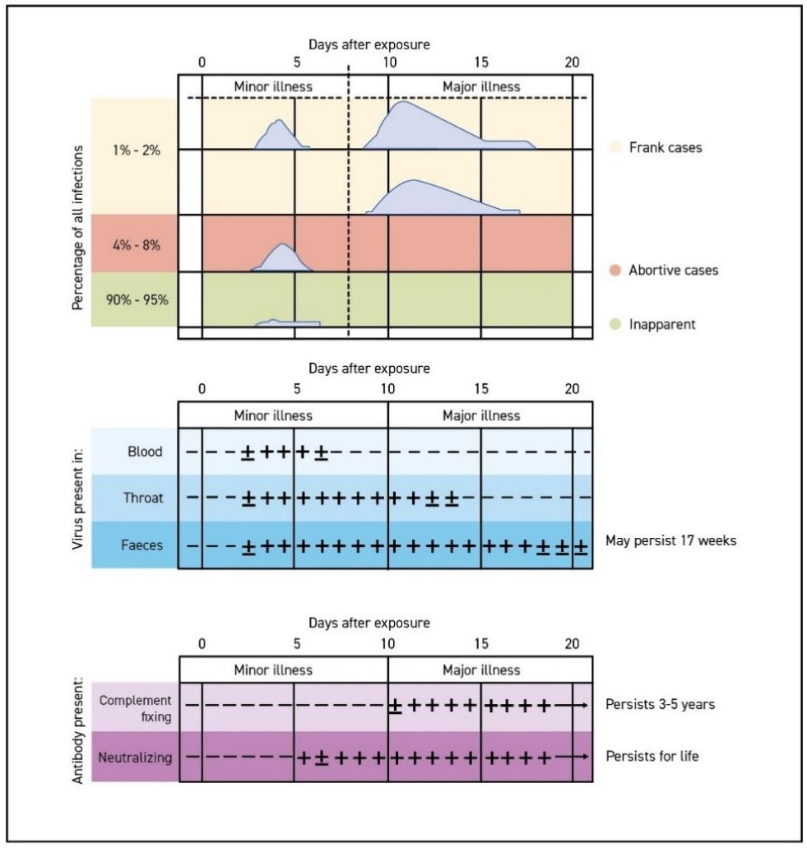

*Figure 7: Timeline of symptoms, presence of virus and development of antibodies following exposure to poliovirus*

*Source:* WHO. Field guide for supplementary activities aimed at achieving polio eradication, Rev. 1996. Geneva: World Health Organization; 1996;4 [(https://apps.who.int/iris/bitstream/handle/10665/63478/WHO_EPI_GEN_95.01_REV.1.pdf)](https://apps.who.int/iris/bitstream/handle/10665/63478/WHO_EPI_GEN_95.01_REV.1.pdf).

**Differential diagnosis of acute flaccid paralysis.** The differential diagnosis of acute flaccid paralysis (AFP) most commonly includes paralytic poliomyelitis, Guillain-Barré syndrome (GBS), traumatic neuritis, and transverse myelitis. Less common etiologies are traumatic neuritis, encephalitis, meningitis, other enterovirus infections and tumors.

Distinguishing characteristics of paralytic polio are asymmetric flaccid paralysis, fever at onset, rapid progression of paralysis, residual paralysis after 60 days and preservation of sensory nerve function.

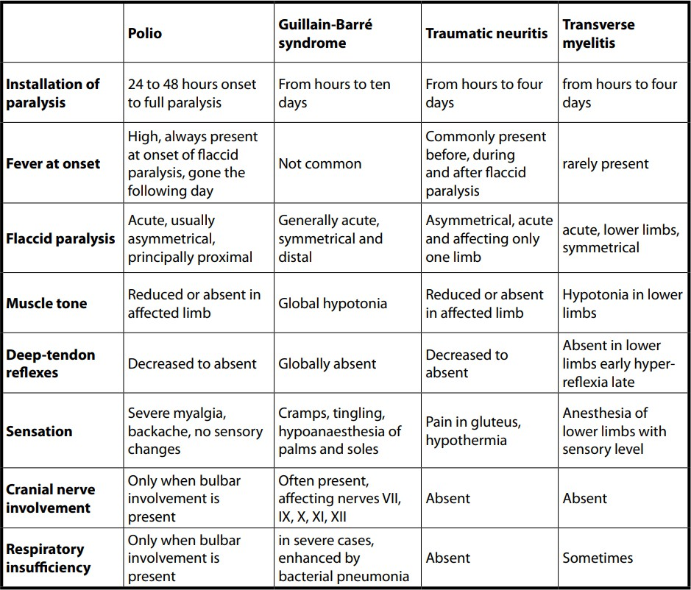

*Figure 8: Differential diagnosis of acute flaccid paralysis (AFP)*

Figure 8 shows a comparison of the four mentioned most common differential diagnoses of AFP. Of note, however, readers are reminded that this information is provided as background for clinicians and health workers. The condition under surveillance, AFP, is a syndrome, not a diagnosis. There are many other possible etiologies and conditions which can manifest with AFP, which should be reported as a syndrome, regardless of the possible diagnosis.

**Clinical case management.** There is no specific treatment for poliomyelitis. Suspected AFP cases should be referred to a hospital immediately for medical care. Any problem with respiration suggesting involvement of the diaphragm requires immediate attention. Supportive care should be given to paralytic cases under physician management.

### Preventing polio

Polio vaccines provide the best protection against polio because they can totally prevent the infection. There are two main types of vaccines against polio: oral poliovirus vaccine (OPV), which contains a weakened form of poliovirus, and injectable, inactivated (or killed) polio vaccine (IPV). You can find details on all types of polio vaccine on a special GPEI website.29

29 Global Polio Eradication Initiative. The Vaccines (webpage). ([https://polioeradication.org/polio-today/polio-prevention/the-](https://polioeradication.org/polio-today/polio-prevention/the-vaccines) [vaccines](https://polioeradication.org/polio-today/polio-prevention/the-vaccines)).

**Oral poliovirus vaccine (OPV).** OPVs are the predominant vaccine used in the fight to eradicate polio (see Table 8). The weakened, or attenuated poliovirus(es) contained in OPV can multiply effectively in the intestinal tract and enables individuals to develop an immune response against the virus. All countries which have eradicated polio since the GPEI began have used OPV to interrupt person-to- person transmission of the virus.

*Advantages*

* OPVs are safe, effective and inexpensive, and because OPV can be given orally, no health professional is required for vaccinating children.
* For several weeks after vaccination, the vaccine virus replicates in the intestine, is excreted and can be spread to, and effectively vaccinating, others in close contact. In areas with poor hygiene and sanitation, immunization with OPV can therefore result in “passive” immunization of people who have no.

*Disadvantages*

* OPV is safe and effective. However, in extremely rare cases (at a rate of approximately 2–4 events per 1 million births), the live, weakened vaccine virus in OPV can itself cause paralysis30. In some cases, this may be triggered by an immunodeficiency. The extremely low risk of vaccine- associated paralytic poliomyelitis (VAPP) is well accepted by most public health programmes.
* Very rarely, when there is insufficient infant immunization coverage in a community, the vaccine virus may begin to circulate, mutate and, over the course of 12 to 18 months, regain neurovirulence, i.e. the ability to cause paralysis. This is known as a circulating vaccine-derived poliovirus (cVDPV)31.

Once polio has been eradicated, all OPV use will be stopped to prevent re-establishment of transmission due to vaccine-derived polioviruses (VDPVs).

###### Table 8: Indications of use for OPVs by serotype

|  |  |  |
| --- | --- | --- |
| **OPV type** | **Serotype** | **Indications for use** |
| **Monovalent oral poliovirus vaccines (mOPVs)** | Type 1 (mOPV1)  Type 2 (mOPV2)  Type 3 (mOPV3) | Elicit the best immune response against the serotype they target. mOPV2 is stockpiled in the event of a cVDPV2 outbreak but is progressively being replaced by nOPV2. |
| **Novel oral polio vaccine type 2 (nOPV2)** | Type 2 (nOPV2) | Provides comparable protection against poliovirus type 2 while being more genetically stable, therefore making it much less likely that VDPV2 will emerge in low-immunity settings.  At the time of writing these guidelines (2023), nOPV2 is being used for type 2 outbreak response, however still under an Emergency Use Listing of the WHO. |
| **Bivalent oral poliovirus vaccine (bOPV)** | Type 1 and type 3 (bOPV) | Contains attenuated virus of serotypes 1 and 3. bOPV elicits a better immune response against poliovirus types  1 and 3 than tOPV, but it does not give immunity against |

30 Platt, Lauren R., Concepción F. Estívariz, and Roland W. Sutter. "Vaccine-associated paralytic poliomyelitis: a review of the epidemiology and estimation of the global burden." The Journal of infectious diseases 210.suppl_1 (2014): S380-S389.

31 Burns, Cara C., Ousmane M. Diop, Roland W. Sutter, and Olen M. Kew. "Vaccine-derived polioviruses." The Journal of infectious diseases 210, no. suppl_1 (2014): S283-S293.

|  |  |  |
| --- | --- | --- |
| **Trivalent oral poliovirus vaccine (tOPV)** |  | serotype 2. Since April 2016, the trivalent oral poliovirus vaccine (tOPV) has been replaced with bOPV in essential immunization and for outbreak response against types 1 and 3 outbreaks. |
| Type 1, type 2 and  type 3 (tOPV) | Withdrawn in April 2016 from essential immunization and replaced with bOPV, tOPV can still be used in outbreak response under specific circumstances, such as co- circulation of type1 and type 2 polioviruses. |

bOPV = bivalent oral polio vaccine; cVDPV2 = circulating vaccine-derived poliovirus type 2; mOPV = monovalent oral polio vaccine; mOPV1 = monovalent oral polio vaccine type 1; mOPV2 = monovalent oral polio vaccine type 2; mOPV3 = monovalent oral polio vaccine type 3; nOPV = novel oral polio vaccine; nOPV2 = novel oral polio vaccine type 2; tOPV = trivalent oral polio vaccine; VDPV2 = vaccine-derived poliovirus type 2; WHO = World Health Organization

**Inactivated poliovirus vaccine (IPV).** IPV consists of inactivated (killed) poliovirus strains of all three poliovirus types. IPV is given by intramuscular or intradermal injection and therefore needs to be administered by a trained health worker. It produces antibodies in the blood to all three types of polioviruses. In the event of infection, these antibodies prevent the spread of the virus to the central nervous system and protect against paralysis.

IPV is used in routine immunization and, in some instances, to respond to polio outbreaks. As IPV does not stop transmission of the virus, OPV is still the vaccine of choice for outbreak response activities even in countries that rely exclusively on IPV for their essential immunization programs.

*Advantages*

* As IPV is not a ‘live’ vaccine and is administered by direct injection (i.e. not excreted by recipients), it carries no risk of VAPP or development of VDPV. It is one of the safest vaccines in use.
* IPV triggers an excellent protective immune response in most people.

*Disadvantages*

* IPV induces very low levels of immunity in the intestine. As a result, when a person immunized with IPV is infected with wild poliovirus, the virus can still multiply inside the intestines and be shed in the faeces, thereby risking continued circulation.
* Administering the vaccine requires trained health workers, as well as sterile injection equipment and procedures.
* IPV is over five times more expensive than OPV.

## Annex 2. Vaccine-derived poliovirus classification and response

There are three categories of vaccine-derived polioviruses (VDPVs), each with a unique classification and associated mode of response (see ).

**Circulating vaccine-derived poliovirus (cVDPV):** Through serial transmission of vaccine virus in an under- vaccinated community, the attenuated (weakened) vaccine polioviruses can regain the neurovirulence and transmission characteristics of wild poliovirus (WPV). VDPVs that have emerged, or have been established through community circulation in under-vaccinated populations, are classified as *circulating vaccine-derived polioviruses* (cVDPVs).

cVDPVs have become an urgent issue for the polio eradication program as cVDPVs, mainly type 2 cVDPVs, have been responsible for thousands of poliomyelitis cases since their first characterization in 2000.32 Strengthening routine immunization systems and conducting supplemental immunization activities (SIAs) are necessary to reduce the risk of cVDPVs emerging. After community transmission has become established, interrupting cVDPV requires outbreak response measures, including high-quality SIAs to reach every child in affected communities.33

**Immunodeficiency-associated vaccine-derived poliovirus (iVDPV):** A far smaller but potentially serious challenge to sustaining global polio eradication in the future is represented by VDPVs that evolve in and are excreted by patients born with inherited primary immunodeficiency disorders (PIDs). PIDs affect the B-cell, antibody-producing part of the immune system. Following receipt of or exposure to oral polio vaccine (OPV) viruses, PID patients may excrete a type of VDPV categorized as *immunodeficiency- associated vaccine-derived polioviruses* (iVDPVs) which can cause paralytic polio in the individual hosting the iVDPV, but more importantly, can potentially re-establish VDPV transmission within a community.

Due to their deficient immune system, some PID patients are unable to stop the replication of OPV virus in their intestinal system and may continue to excrete iVDPV for months or years. The PID patient may eventually experience polio paralysis, and the excreted virus may start to circulate in the patient's community. To reduce the risk posed by iVDPVs to the individual PID patient and and the community during the polio endgame and the post-eradication era, it will be important to establish surveillance for PID patients and iVDPV. Once country programs identify non-paralytic PID patients excreting polioviruses, iVDPV surveillance provides strategies and treatments to rid both the individual and the community of the risk posed by iVDPVs.34

**Ambiguous vaccine-derived poliovirus (aVDPV)**: A final category of poliovirus is called *ambiguous vaccine-derived poliovirus* (aVDPV). The term 'ambiguous' is used because the virus is neither c- nor iVDPV: it is not isolated from an individual with known immunodeficiency, nor can it be linked (yet) genetically to previously known VDPVs. aVDPVs may be an early indication of the possibility of a cVDPV developing, and therefore surveillance needs to be ramped up as soon as one is detected.

32 Public Health Dispatch: Outbreak of Poliomyelitis --- Dominican Republic and Haiti, 2000. MMWR Morb. Mortal. Wkly. Rep. 2000;49(48);1094,1103 [(https://www.cdc.gov/mmwr/preview/mmwrhtml/mm4948a4.htm](https://www.cdc.gov/mmwr/preview/mmwrhtml/mm4948a4.htm)).

33 Global Polio Eradication Initiative (GPEI). Standard operating procedures: responding to a poliovirus event or outbreak, version 4. Geneva: World Health Organization; 2022 [(https://polioeradication.org/wp-content/uploads/2022/07/Standard-Operating-Procedures-For-Responding-](https://polioeradication.org/wp-content/uploads/2022/07/Standard-Operating-Procedures-For-Responding-to-a-Poliovirus-Event-Or-Outbreak-20220807-EN-Final.pdf) [to-a-Poliovirus-Event-Or-Outbreak-20220807-EN-Final.pdf](https://polioeradication.org/wp-content/uploads/2022/07/Standard-Operating-Procedures-For-Responding-to-a-Poliovirus-Event-Or-Outbreak-20220807-EN-Final.pdf)).

34 Global Polio Eradication Initiative (GPEI). Guidelines for Implementing Poliovirus Surveillance among Patients with Primary Immunodeficiency Disorders (PIDs), revised 2022. Geneva: World Health Organization; 2022 [(https://polioeradication.org/wp-](https://polioeradication.org/wp-content/uploads/2022/06/Guidelines-for-Implementing-PID-Suveillance_EN.pdf) [content/uploads/2022/06/Guidelines-for-Implementing-PID-Suveillance_EN.pdf](https://polioeradication.org/wp-content/uploads/2022/06/Guidelines-for-Implementing-PID-Suveillance_EN.pdf)).

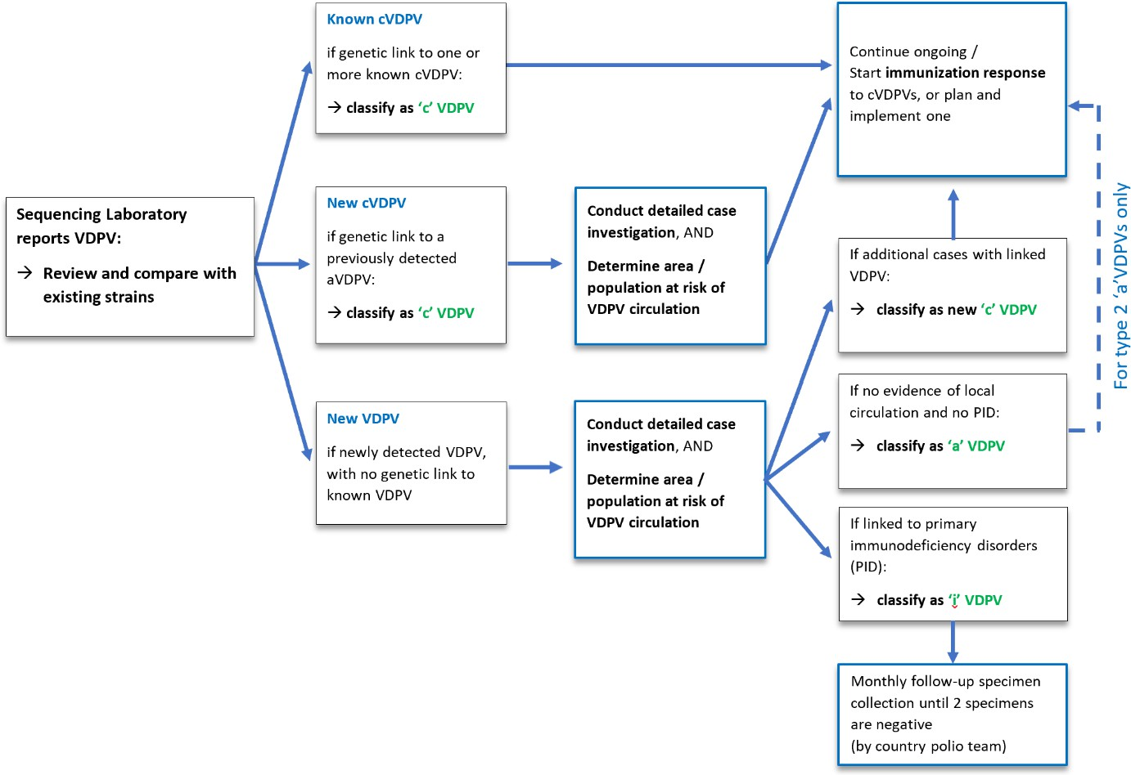

*Figure* *9 : Classification of and response to reported VDPV isolates*

Note: Note that the classification of VDPV isolates is done by the sequencing laboratory in collaboration with the WHO regional polio team. aVDPV = ambiguous vaccine-derived poliovirus; cVDPV = circulating vaccine-derived poliovirus; iVDPV = immunodeficiency-associated vaccine-derived poliovirus; PID = primary immunodeficiency disorder; VDPV = vaccine-derived poliovirus. *Source*: GPEI. Classification and reporting of vaccine-derived polioviruses (VDPV). Geneva: World Health Organization; 2016 [(https://polioeradication.org/wp-content/uploads/2016/09/Reporting-and-Classification-of-](https://polioeradication.org/wp-content/uploads/2016/09/Reporting-and-Classification-of-VDPVs_Aug2016_EN.pdf) [VDPVs_Aug2016_EN.pdf](https://polioeradication.org/wp-content/uploads/2016/09/Reporting-and-Classification-of-VDPVs_Aug2016_EN.pdf)).

## Annex 3. Timeline of poliomyelitis and polio eradication in the African Region

|  |  |
| --- | --- |
| **1918** | First large polio epidemic recognized in South Africa |
| **1948** | SA's largest polio outbreak w. 3,000 cases, 200 deaths - Polio Research Foundation in 1950. |
| **1949-54** | Large polio epidemics in Angola, DRC, French Eq. Africa, Kenya, Zimbabwe, Uganda, SA. |
| **1961-62** | Polio cases increase in 24 of 34 African countries reporting polio cases to WHO |
| **1974** | 168,000 polio cases estimated in Africa yearly – much higher than suspected. Estimate based  on ‘lameness surveys’ conducted in 14 African countries, starting with Ghana. |
| **1976** | SA: Polio Research Foundation Lab opens, later becomes National Institute for Virology |
| **1988** | WHA resolution to eradicate polio worldwide, launch of ‘Global Polio Eradication Initiative’ |
| **1989** | WHO Africa Reg. Committee adopts 1988 WHA resolution, endorses reg. eradication goal |

|  |  |
| --- | --- |
| **1996** | OAU adopts Yaoundé Declaration to eradicate polio in Africa. Nelson Mandela launches ‘Kick Polio out of Africa’ campaign |
| **1999** | First house-to-house polio campaigns conducted in Nigeria; UN negotiates ceasefire between warring parties in DRC to allow ten million children to be immunized against polio; huge type 3 outbreak of polio in Luanda, Angola |
| **2003** | Boycott of polio vaccine in N. Nigeria: outbreak spreading to 20 countries worldwide by 2008 |
| **2005** | Importation of wild polio 1 from India: outbreaks in Luanda, Angola, and 2006 in Namibia |
| **2008** | WHO calls on Nigeria to respond swiftly to a polio outbreak affecting 15 countries in west- central Africa by 2010, followed by synchronized cross-border campaigns across the region |
| **2011** | Environmental surveillance for poliovirus used for the first time in Nigeria, first in the Region |
| **2012** | Nigeria accounts for 50% of the world’s wild polio cases. - Nigeria sets up Polio Emergency Operations Center launches a national emergency plan, which accelerates progress. |
| **2013** | Wild PV 1 type 1 outbreak in Somalia spreads to Ethiopia and Kenya - trigger for large-scale vaccination campaigns across Horn of Africa countries |
| **2014** | WHO declares wild polio and cVPDVs as Public Health Emergency of International Concern |
| **2015** | Wild poliovirus 2 declared eradicated globally; last case of WPV2 found in India in 1999. |
| **2016** | After 3 years without wild polio case, 4 cases again detected in NE Nigeria around Lake Chad. Huge Lake Chad emergency response targets over 45 million children in 5 countries |
| **2016** | 155 countries and territories worldwide, including across Africa, switch from ‘trivalent’ OPV to ‘bivalent’ OPV, which does not contain the eradicated type 2 strain |
| **2016** | Independent review in 8 African countries: polio has provided major benefits to Africa’s  health systems, incl. for disease surveillance, routine immunization and outbreak response. |
| **2017** | DRC sees a wave of cVDPV2 outbreaks that leaves 29 children paralyzed |
| **2018** | Increase in reported cVDPV cases across all regions in Africa. Cases reported in 12 countries |
| **2019** | Wild poliovirus type 3 is certified to have been eradicated globally. |
| **2019** | WHO AFRO sets up Rapid Response Team to coordinate responses to cVDPV outbreaks. |
| **2019** | Nigeria 3 years wild polio free - regional wild polio-free certification process starts |
| **2020** | ARCC certifies WHO African Region wild polio-free after > 4 years without wild polio detected by certification-standard disease surveillance |
| **2021-23** | Continued cVDPV outbreaks; in 2022, cVDPV2 cases in 15, and cVDPV1 cases in 5 AFR countries |
| **2022** | Wild polio 1 importation from Pakistan into SE Africa - cases in Malawi, Mozambique; WPV1 transmission interrupted by end-2022 |

## Annex 4. Quality indicators for AFP surveillance

Core timeliness indicators, as introduced by the GPEI 2022-2026 Strategy, reflect the overall capacity of the programme to rapidly identify any wild poliovirus (WPV) or vaccine-derived poliovirus (VDPV).

This capacity has been defined as: (1) the capacity of the programme to report a positive acute flaccid paralysis (AFP) case rapidly so that a response can be mounted fast; and (2) the capacity to process

rapidly any positive specimen (**Table 3.1**). Additional indicators highlight the capacity of the programme to report any laboratory results rapidly, regardless of the final result.

For certification purposes, in all countries, the definitions and thresholds for stool specimen collection and adequacy will remain unchanged (i.e. stool adequacy target of at least 80% AFP cases with *2 specimens collected at least 24 hrs apart, both within 14 days* of paralysis *onset, and received in good condition in a WHO-accredited polio laboratory*).

However, the Global Polio Surveillance Action plan 2022 to 2024 identified a list of 'priority countries'35, mainly in the African Region, where a new standard should be applied as programmatic target, to improve the timeliness of detection:

* two adequate stool specimens be **collected from all AFP cases and reach the laboratory in good condition within 14 days of the onset of paralysis** (i.e., 2 specimens collected within 11 days of onset, reaching the laboratory within 3 days of collection, see Figure 2 below)
* testing and sequencing and/or whole genomic sequencing results, i.e., the **final results of lab testing, should be reported within 35 days** of the onset of paralysis.

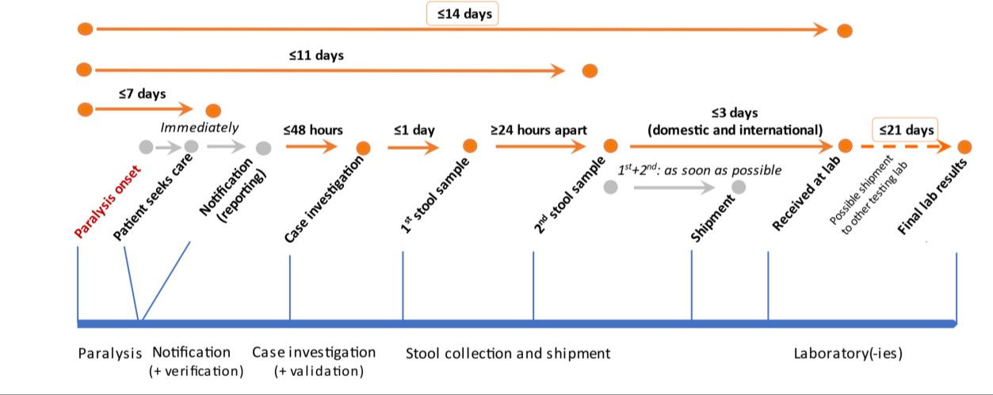

*Figure 10: Timeliness of detection (AFP cases), 35 days (onset to final lab result)*

###### Table 9: Overall indicators on timeliness

|  |  |  |  |
| --- | --- | --- | --- |
| **Indicator** |  | **Calculation (expressed as a percentage)** | **Target** |
| **Overall detection of WPV/VDPV** | For AFP (1) | # of AFP cases* with WPV/VDPV final lab results  <=35 days of onset  /  # of AFP cases* with WPV/VDPV final lab results | >=80% |
| System capacity (2)† | # of WPVs and VDPVs with final lab results <=35 days of  onset for AFP cases  /  # of WPVs and VDPVs | >=80% |
| **AFP detection – system** | | # of AFP cases* with final lab results <=35 days of onset  /  # of AFP cases* | >=80% |

35 Countries were identified as “priority countries” due to persistent gaps in surveillance and chronic vulnerability to poliovirus transmission. As of publication of the GPSAP in early 2022, 20 of the 30 priority countries identified worldwide were in the WHO African Region.

AFP = acute flaccid paralysis; VDPV = vaccine-derived poliovirus; WPV = wild poliovirus

*Aggregated results: all lab results (AFP + contacts) used to classify AFP case as confirmed/discarded.

†Specimen-based calculation

###### Table 10: Indicators on timeliness for field activities

|  |  |  |
| --- | --- | --- |
| **Indicator** | **Calculation (expressed as a percentage)** | **Target** |
| **Timeliness of notification** | # of AFP cases reported <=7 days of onset  /  # of AFP cases | >=80% |
| **Timeliness of investigation** | # of AFP cases investigated <=48 hours of notification  /  # of AFP cases | >=80% |
| **Timeliness of field activities** | # of AFP cases with 2 **stool specimens** collected >=24 hrs apart AND <=11 days of onset  /  # of AFP cases | >=80% |
| **Timeliness of field and shipment activities** | # of AFP cases with 2 **stool specimens** collected >=24 hours  apart AND received in good condition* at a WHO-accredited laboratory AND <=14 days of onset  /  # of reported AFP cases | >=80% |
| **Timeliness of stool specimen shipment** | # of **stool specimens** that arrive in good condition* at a WHO-  accredited lab AND <=3 days of specimen collection  /  # of **stool specimens** collected | >=80% |

AFP = acute flaccid paralysis; WHO = World Health Organization

*For calculations: missing stool condition = poor condition

###### Table 11: Indicators on timeliness for laboratory activities

|  |  |  |
| --- | --- | --- |
| **Indicator** | **Calculation (expressed as a percentage)** | **Target** |
| **AFP: Timeliness of reporting laboratory results (system performance)** | # of **stool specimens** with final lab results available <=21 days from a direct detection country OR <=28 days from a non-direct detection country of receipt at a WHO-accredited lab  /  # of stool specimens collected | >=80% |
| **AFP: Timeliness of reporting WPV/VDPV results (detection)** | # of **stool specimens** with WPV/VDPV final lab results available <=21 days of receipt from a direct detection country OR <=28 days of receipt from a non-direct detection country at a WHO-accredited lab  /  # of **stool specimens** collected positive for WPV/VDPV | >=80% |
| **AFP: Timeliness of reporting poliovirus laboratory results** | # poliovirus **stool specimens** with sequencing results available <=7 days of receipt at a WHO-accredited sequencing lab  /  # of PV **stool specimens** positive by ITD requiring sequencing | >=80% |

AFP = acute flaccid paralysis; ITD = intratypic differentiation; VDPV = vaccine-derived poliovirus; WHO = World Health Organization; WPV = wild poliovirus

###### Table 12: Core indicators on AFP surveillance quality

|  |  |  |
| --- | --- | --- |
| **Indicator** | **Calculation** | **Target** |
| **NPAFP rate\*** | (# of cases discarded as NPAFP in children <15 years of age  /  # of children <15 years of age) x  100 000 per year  Note: Endemic countries are encouraged to have >=3 | AFR, EMR, SEAR: >=2 AMR, EUR, WPR: >=1  OB-affected:† >=2 |
| **NPAFP rate – subnational** | (# of districts with >=100 000 children <15 years old that meet the  NPAFP rate target  /  # of districts with >=100 000 children <15 years old) x  100  Note: Need to reach >=3 per 100,000 in all high-risk districts within an outbreak country | AFR, EMR: >=80%  SEAR: >=50%  AMR, EUR, WPR: NA  OB-affected districts:* 100% |
| **Stool adequacy** | (# of AFP cases with 2 stool specimens collected >=24 hours apart AND <=14 days of onset AND received in good condition‡ in a WHO-accredited laboratory  /  # of AFP cases) x  100  Note: Certification indicator (14 days) | ≥80% |

AFP = acute flaccid paralysis; AFR = African Region; AMR = Region of the Americas; EMR = Eastern Mediterranean Region;

EUR = European Region; NA = not applicable; NPAFP = non-polio acute flaccid paralysis; OB = outbreak; SEAR = South-East Asia Region; WHO = World Health Organization; WPR = Western Pacific Region

*Rate should be annualized.

†Outbreak-affected country is defined as: any country experiencing an outbreak of WPV or circulating vaccine-derived poliovirus (cVDPV) currently or in the previous 12 months.

‡For calculation: missing stool condition = poor condition

**Table 12 (continued)**

|  |  |  |
| --- | --- | --- |
| **Indicator** | **Calculation (expressed as a percentage)** | **Target** |
| **Stool adequacy – subnational** | (# of districts that reported >=5 AFP cases that meet the stool  adequacy target  /  # of districts that reported >=5 AFP cases) x  100 | ≥80% |
| **Stool timeliness** | (# of AFP cases with 2 stool specimens collected >=24 hrs  apart, AND <=14 days of onset  /  # of reported AFP cases) x  100  Note: Certification indicator (14 days of onset) | ≥80% |
| **Stool condition** | # of AFP cases with two **stool specimens** arriving in good  condition* at a WHO accredited lab  /  # of reported AFP cases | >=80% |
| **Composite index – national** | Population living in districts that meets both NPAFP rate target and stool adequacy target  /  Population living in all districts (Admin2) | >=80% |

|  |  |  |
| --- | --- | --- |
| **Composite index – subnational** | # of districts with ≥100,000 children <15 years old that meet NPAFP rate target and stool adequacy target  /  # of districts with ≥100,000 children < 15 years of age | >=80% |
| **Adequacy of active surveillance visits†**  **(2 calculations)** | 1. # visits to HP sites conducted / # HP site visits planned 2. # HP sites visited / Total # HP sites | 1. >=80%  2. 100% |
| **Completeness of 60- day follow-ups** | # of inadequate AFP cases with a follow up exam for residual  paralysis completed >=60 days AND <= 90 days of onset  /  # of inadequate AFP cases | >=80% |
| **Completeness of weekly zero reporting (WZR)** | # of sites reporting  /  # of designated reporting sites for AFP surveillance | >=80% |
| **Timeliness of WZR** | # of sites reporting by the deadline  /  # of designated reporting sites for AFP surveillance | >=80% |

AFP = acute flaccid paralysis; HP = high-priority; NPAFP = non-polio acute flaccid paralysis; WZR = weekly zero reporting

*For calculation: missing stool condition = poor condition

†(a) High-priority sites are those facilities where there is a high likelihood of seeing an AFP case; they are visited at least on a weekly basis and sometimes more often, (b) Combination indicator in which “all HP sites have >=1 visit each month” to be used as a flag, (c) Calculated per month.

###### Table 13: Non-core indicators on AFP surveillance*†

|  |  |  |
| --- | --- | --- |
| **Indicator** | **Calculation (expressed as a percentage)** | **Target** |
| **Unreported AFP cases found during active surveillance** | # of unreported AFP cases found in the register during active surveillance visits  /  month | None |
| **Percentage of supervised active surveillance visits‡** | # of active surveillance visits supervised per month  /  # of active surveillance visits conducted per month | >=25% |
| **Number of active surveillance visits in high-priority sites** | >=4 visits per month to the HP site  /  # of visits planned to the HP site | 100% |
| **AFP case field validation**  **Note: as opposed to a clinical validation; would be done by a supervisor or higher than the person who reported the case** | # of AFP cases validated <=14 of investigation  /  # of AFP cases | >=50% |
| **Completeness of**  **AFP contact sampling** | # of inadequate AFP cases with contact sampling§  /  # of inadequate AFP cases | >=80% |
| **Timeliness of**  **AFP contact sampling** | # of contact stool specimens of inadequate cases collected <=7 of days of investigation  /  # of contact stool specimens of inadequate cases | >=80% |

AFP = acute flaccid paralysis; HP = high-priority

* For priority countries (very high risk, high risk, and medium-high risk), indicators should be analysed monthly.

† For non-priority countries, indicators should be reviewed quarterly and included in desk reviews.

‡ Calculated by priority site, by geography, and by quarter.

§ 2 or 3 contact samples per inadequate AFP case, as per regional recommendation.

###### Table 14: Non-core indicators on health-seeking behaviours*†

|  |  |  |
| --- | --- | --- |
| **Indicator** | **Calculation (expressed as a percentage)** | **Target** |
| **AFP case encounters‡** | # of AFP cases with <=2 health encounters between onset and notification  /  # of AFP cases | >=80% |
| **Adequacy of notification by designation** | # of 1st health encounters that led to a notification, by designation [reporting source]§  /  # of health encounters by that same designation | >=80% |
| **Appropriateness of surveillance network** | # of AFP cases with first health encounters with a reporting site within the AFP surveillance network  /  # of AFP cases | >=80% |
| **Late reported AFP cases: Completeness of health encounter information** | Among AFP cases reported >14 days after paralysis onset: # of AFP cases with no information on health encounters  /  # AFP cases reported >14 days after paralysis onset | >=80% |

AFP = acute flaccid paralysis

* For priority countries (very high risk, high risk, medium-high risk), indicators should be analysed monthly**.**

† For non-priority countries, indicators should be reviewed quarterly and included in desk reviews.

‡ Results should be stratified by sex.

§ This is the “percentage of 1st encounters by designation (e.g., doctor, nurse, traditional healer, vaccinator, other) that led to the notification of an AFP case.”

###### Table 15: Non-core indicators on community-based surveillance

|  |  |  |
| --- | --- | --- |
| **Indicator** | **Calculation (expressed as a percentage)** | **Target** |
| **Proportion of AFP cases reported by CBS** | # of AFP cases (those on linelist) identified by community informant  /  # of AFP cases on linelist | TBD |
| **Proportion of ‘verified’ AFP reported by CBS** | # of ‘suspect’ AFP cases identified by community informant  /  # of AFP cases ‘verified’ by surveillance officers | TBD |
| **Completeness of weekly/monthly zero reporting (WZR/MZR)** | # of reports received from community informants  /  # of expected reports from community informants | >=80% |
| **Timeliness of WZR/MZR** | # of reports received on time from community informants  /  # of expected reports from community informants | >=80% |
| **Proportion of female informants** | # of female informants  /  # of informants | >=50%-80%* |
| **Proportion of informants from local area** | # of local informants  /  # of informants | >=80%* |

AFP = acute flaccid paralysis; CBS = community-based surveillance; MZR = monthly zero reporting; TBD = to be determined; WZR = weekly zero reporting

*Target to be adjusted at the country level; priority countries to regularly analyse.

**Table 15 - continued**

|  |  |  |
| --- | --- | --- |
| **Indicator** | **Calculation (expressed as a percentage)** | **Target** |
| **Supervision of informants† ‡** | # of informants who have received at least one supervisory visit in last 3 months  /  # of informants | >=80% |
| **Informant training‡ §** | # of informants with training within the last year  /  # of informants | >=80% |
| **Informant turnover rate‡ § ¶** | # of informants who left during the previous year  /  # of informants | TBD |

† To be reviewed quarterly; priority countries to regularly analyse. Suggest to stratify results by supervisor.

‡ Results should be stratified by sex.

§ To be reviewed annually; priority countries to regularly analyse.

¶ Informant turnover rate is a flag; the target is to be defined at the country level. The calculations should be based on the number of informants at the beginning of the review period.

###### Table 16: Gender-related indicators

|  |  |
| --- | --- |
| **Indicators** | **Calculation (expressed as a percentage)** |
| **Case detection** | # of AFP cases* by sex with final lab results ≤35 days of onset  /  # of AFP cases |
| **Timeliness of field activities** | # of AFP cases by sex with 2 samples collected ≥ 24 hrs apart, both within 11 days of paralysis onset  /  # of reported AFP cases |
| **Timeliness of notification** | # of AFP cases by sex reported within 7 days of paralysis onset  /  # of reported AFP cases |
| **Health contact** | # of AFP cases by sex with ≤2 healthcare encounters between onset and before notification  /  # of AFP cases |
| **Professional profile by sex (by category)** | # of women [professional profile]  /  total # of staff or informants (by category: surveillance officer, supervisor, CBS informant) |
| **Staff with completed PRSEAH** | # of surveillance staff having completed PRSEAH training  /  # of staff |

AFP = acute flaccid paralysis; CBS = community-based surveillance; PRSEAH = preventing and responding to sexual exploitation, abuse and harassment

*Aggregated results: all lab results (AFP + contacts) used to classify AFP case as confirmed/discarded

## Annex 5. Examples of forms

###### - Active surveillance visit form

###### Active surveillance (AS) for acute flaccid paralysis (AFP)

Name of officer: Date of visit:

Year Month of visit:

Province: District:

Name of health facility (+ other identifier):

|  |  |  |  |  |  |
| --- | --- | --- | --- | --- | --- |
| No. | Item | Status | | | Remarks |
| 1 | Interview with: | | | | |
| 1.1 | Doctor in charge | Yes | No | N/A |  |
| 1.2 | AFP / surveillance focal point | Yes | No | N/A |  |
| 1.3 | Pediatrician of the facility | Yes | No | N/A |  |
| 1.4 | Neurologist of the facility | Yes | No | N/A |  |
| 1.5 | Physiotherapist of the facility | Yes | No | N/A |  |
| 1.6 | Other health facility staff. *Specify*: | Yes | No | N/A |  |
| 2 | Check for new / missed AFP cases: | | | | Details of new AFP cases: |
| 2.1 | Outpatient register (OPD) checked for AFP cases | Yes | No | N/A |  |
| 2.2 | Inpatient register (IPD) checked for AFP cases | Yes | No | N/A |  |
| 2.3 | Internal medicine department / ward | Yes | No | N/A |  |
| 2.4 | Neurology unit | Yes | No | N/A |  |
| 2.5 | Orthopedic department | Yes | No | N/A |  |
| 2.6 | Physiotherapy unit | Yes | No | N/A |  |
| 2.7 | Other departments / units / wards. *Specify*: | Yes | No | N/A |  |
| 3 | Check for supplies and material availability: | | | | |
| 3.1 | Stool specimen kit(s) | Yes | No | N/A |  |
| 3.2 | Specimen carrier(s) | Yes | No | N/A |  |
| 3.3 | AFP poster(s) visible in the facility | Yes | No | N/A |  |
| 4 | *Summary*:  New and unreported cases *since last visit*: | New  (all new) | Unreported  (out of the new cases found) | | If already reported, write EPID no. |
| 4.1 | Number of AFP cases found during this visit, since the last visit |  |  | |  |
| 5 | Feedback: | Number | | | EPID of cases for result pending |
| 5.1 | Number of AFP cases for which results have not reached the facility in >60 days |  | | |  |
| 6 | Other checks done: | | | | Remarks |
| 6.1 | Vaccine cold chain fully functional | Yes | No | N/A |  |
| 6.2 | Polio vaccine in stock | Yes | No | N/A |  |
| 6.3 | *Other*: | Yes | No | N/A |  |
| Name of person in charge of facility: | | | | | |
| Signature of person in charge of facility: | | |  |  | Date: |
| Signature of officer: | | |  |  | Date: |

###### - Case investigation form (used since December 2020 in all countries in AFRO)

Official Use

### POLIO ERADICATION PROGRAMME: ACUTE FLACCID PARALYSIS CASE INVESTIGATION FORM

Only: EPID Number: - - - - Received: / / Country Region/Prov. Districts Year onset Case Number by the Programme at National level

IDENTIFICATION **Name nearest** Health

District: Region/Province: Facility: Address: Village: City:

AFP case coordinates (*WGS 1984 format*) : Longitude : Latitude :

Patient name: Father/Mother:

Date of Birth (DOB) / / Age: years months M=Male

(If DOB Unknown) Sex: F=Female

NOTIFICATION/INVESTIGATION:

Date of Date of

Notified by: Notification / / Investigation: / /

HOSPITALIZATION Hospitalized: 1=Y Date of admission to hospital, if applicable:  **/ /**

2=N

Hospital record #: Name of hospital/Address:

CLINICAL HISTORY Fever at the onset Progressive Paralysis of paralysis? < 3 d

1=Y, 2=N, 99=Unknown 1=Y, 2=N, 99=Unknown

ays**?**

Date of onset: Is Paralysis Asymmetric? Site of Paralysis

of paralysis: / / flaccid and acute?

LA RA

LL RL

1=Y, 2=N, 99=Unknown 1=Y, 2=N, 99=Unknown

Paralysed limb (s) Sensitive to pain: Yes/No Was there any injection just before onset of paralysis: Yes/No

If yes mention the site of injection in the table below

|  |  |  |  |  |  |
| --- | --- | --- | --- | --- | --- |
|  | **Arm** | **Fore-arm** | **Buttocks** | **Thigh** | **Leg** |
| **Right** |  |  |  |  |  |
| **Left** |  |  |  |  |  |

**PROVISIONAL DIAGNOSIS----------------------------------------------------------------------------------------------------------------------------------**

AFTER INVESTIGATION, WAS THIS A TRUE AFP? 1=Y If not, do not fill the rest of the form and record 6 under

2=N final classification

**IMMUNIZATION HISTORY**

Total Number of Exclude OPV dose at birth  **/ /** 2nd  **/ /** 4th  **/ /**

Polio vaccine doses dose at birth If > 4

1st  **/ /** 3 rd **/ /** Last  **/ /**

99=Unknown dose

Total OPV doses received through SIA:  99=Unknown Total OPV doses received through RI:  99=Unknown.

Date of last OPV dose received through SIA: / /

Total IPV doses received through SIA:  99=Unknown Total IPV doses received through RI  99=Unknown

Date of last IPV dose received through SIA: / / Source of RI vaccination information: Card Recall Choose one

|  |  |  |  |
| --- | --- | --- | --- |
| **STOOL SPECIMEN COLLECTION:** | **/ /** | **/ /** | **/ /** |
| Date 1st specimen  to the national level | Date 2nd specimen | Date specimen sent to the |  |

/ / / /

Date specimen received at Date specimen sent

the national level inter-county/national Laboratory

**STOOL SPECIMEN RESULTS:**

/ / 1= Adequate / / / / / / Date specimen received at 2=Not adequate Date combined Cell Culture Date Results sent to Date Results received at inter country (I-C)/national Lab Results available national EPI national EPI

Status of specimen at

Reception at the lab Final cell 1=Suspected poliovirus

Culture Results 2= Negative

3=NPENT

4-Suspect poliovirus + NPENT

/ / / / / / Date sent from I-C/National Date I-T differentiation Date I-T differentiation Laboratory to regional lab results sent to EPI results received at EPI

W1 W2 W3

Discordant

Sabin SL1 SL2 SL3

(R) NPENT NEV

1=Y, 2=N

Type 1,2,3

1=Y, 2=N

1=positive, 2=Negative

/ / / /

Date isolate sent for sequencing Date seq results sent to program

**FOLLOW-UP EXAMINATION**

1 = Residual Flaccid Paralysis

Final Lab Results

/ / Residual LA Results 2= sidual paralysis Date of Follow-up exam. Paralysis? f exam 3= Lost follow-up

RA

o

No re

LL RL 4=Died before follow-up

5= Residual Spastic Paralysis

Immunocompromised status suspected:  1=Y, 2=N, 99=Unknown

**FINAL CLASSIFICATION**

1=Confirmed Polio 7=cVDPV ero-type (1, 2, 3) 2=Compatible

S

3=Discarded 8=aVDPV

6=Not an AFP case

9=iVDPV

***Fill in this section before signing the form***

Where has the child been seeking help for this problem before presenting at present place (in sequence of visits)?

(1). Place: Duration: months days (2) Place: Duration: months days

(3). Place: Duration: months days (4) Place: Duration: months days

**INVESTIGATOR:** Name Title

Unit: Address Tel:

|  |  |  |  |  |  |  |  |  |  |  |  |  |
| --- | --- | --- | --- | --- | --- | --- | --- | --- | --- | --- | --- | --- |
| **Contact Stool Collection Form – (for inadequate AFP cases)** | | | | | | | | | | | | |
| EPID number of contact  *(index AFP EPID number – C1, C2 or C3* | | |  | | | | | | | | | |
| EPID number of community sample  CCC-PPP-DDD-YY-000CC1 etc | | |  | | | | | | | | | |
| Reason for collection | | | Inadequate | | Hot case | | | Hard-to-reach area | | | Other | |
| Name of contact/Community case | | |  | | | | | | | | | |
| Address | | |  | | | | | | | | | |
| Area | | |  | | | | | | | | | |
| District | | |  | | | | | | | | | |
| Province | | |  | | | | | | | | | |
| Country | | |  | | | | | | | | | |
| Specimen number (in case of multiple samples from contact) |  | | | | | | | | | | | |
| Date of stool collection |  | | | | | | | | | | | |
| Date stool sent to laboratory |  | | | | | | | | | | | |
| Name of Index Case |  | | | | | | | | | | | |
| Relation to index case | Househ old relative | | | Household non-relative | | Out-of- household relative | | | Neighbor | Playmate/ Schoolmate | | Other |
| Period of Exposure to Index AFP cases | ( ) more than 7 days prior to onset of paralysis ( ) within 7 days prior to onset of paralysis  ( ) within 2 weeks after onset of paralysis or N/A | | | | | | | | | | | |
| Date of birth or  Age in months | / / months | | | | | | | | | | | |
| Sex | Male | | | | | | Female | | | | | |
| Number of routine OPV/IPV doses | |  | | | | | | | | | | |
| Number of SIA OPV/IPV doses | |  | | | | | | | | | | |
| Date of last OPV/IPV | |  | | | | | | | | | | |
|  | | | | | | | | | | | | |
| Date stool received at laboratory | |  | | | | | | | | | | |
| Laboratory serial number | |  | | | | | | | | | | |

|  |  |
| --- | --- |
| Date culture results sent from lab to EPI |  |
| Comment and Signature |  |

###### Instructions:

1. Systematically Collect 1 specimen from 3 contacts of all All inadequate AFP cases.
2. Prioritize contacts under 5 years of age living in the same house as the AFP case.
3. If there are less than 5 contacts in the house, choose the closest playmates or neighbors of the AFP case
4. Fill a contact specimen collection form for each contact. Or separate form for each community case.
5. Use the same specimen collection procedures and reverse chain as for the AFP case specimen collection.
6. Use a separate vaccine carrier for contact specimens and the AFP case specimens. C=Contact

CC= Community sample

###### Signature:

###### - Detailed case investigation form

The main elements to include in a detailed case investigation form (CIF) or report are:36

|  |  |
| --- | --- |
| * **Case notification**   + Name and unique epidemiological identification (EPID) number   + Date of notification   + Name of respondent and relationship with case   + Name of interviewer, contact information and affiliation   + Date of case investigation * **Demographic**   + Residence (province, district, village, etc.)   + Date of birth, age   + Sex * **Vaccination**   + Total number of oral polio vaccine (OPV) doses received in essential immunization (incl. code for unknown, i.e., 99)   + Total number of OPV doses received during supplemental immunization activities (SIAs) (incl. code for unknown, i.e., 99)   + Total number of inactivated polio vaccine (IPV) doses received in essential immunization (incl. code for unknown, i.e., 99)   + Total number of IPV doses received in SIAs (incl. code for unknown, i.e., 99)   + Date of last OPV dose * **Clinical information**   + Date of paralysis onset   + Fever at onset of paralysis?   + Asymmetric paralysis?   + Neurological examination | * **Risk factors**   + Occupation of parents/caregivers   + Ethnicity   + Special population (check all that apply): refugee, internally displaced population (IDP), reside in security- challenged area, migrant/mobile population   + Travel history of case and household members (outside of district or country) within one (1) month of onset of paralysis   + History of attendance at gathering of case and household members (large scale market/fair, other) within one (1) month of onset of paralysis   + History of visitors to the household within one (1) month of onset of paralysis * **Specimens**   + Specimen numbers   + Date of collection of stool specimens   + Date stool specimen received in laboratory   + Condition of stool (good, poor, unknown) * **Laboratory results** * **History of care-seeking prior to notification**   + Name and location of sites / facilities visited by the case between onset and notification   + Dates of visits * **Other AFP cases in area?** * **Geographic and demographic information, population size of area** * **Rapid OPV/IPV coverage survey of area** * **Essential immunization and SIA coverage** * **Map** |

If the polio isolate was detected through environmental surveillance (ES), special focus should go towards understanding the catchment area of this ES site, the sociodemographic characteristics and level of vaccination coverage of the population living in that catchment area. In addition, the investigation should look for missed AFP cases in/around the ES site catchment area.

36 An example of a detailed case investigation form can be found on the GPEI website ([http://polioeradication.org/wp-](http://polioeradication.org/wp-content/uploads/2016/09/Detailed-Case-Investigation-Form_July2011_EN.doc) [content/uploads/2016/09/Detailed-Case-Investigation-Form_July2011_EN.doc](http://polioeradication.org/wp-content/uploads/2016/09/Detailed-Case-Investigation-Form_July2011_EN.doc)).

###### - 60-day follow-up examination form

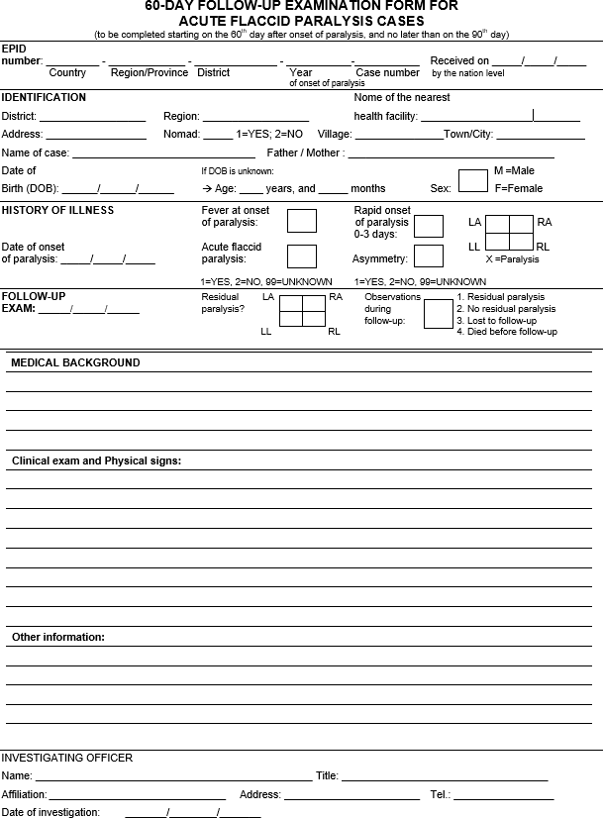

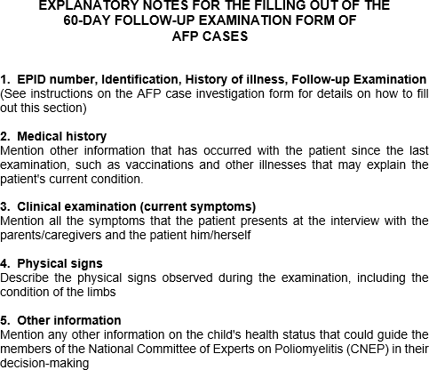

## Annex 6. AFP case investigation

* 1. **How to document the AFP case history**. While observing the patient for signs of paralysis or

weakness, the surveillance officer should take the history of the case from the patient’s caregiver (or the

patient, if an older child), transcribing key elements on the case investigation form (CIF), including:

1. Patient identification
   * Patient / caregiver identification (names, address or location, mobile phone, etc.) that will be key to tracing the family back, if needed.
   * Date of onset of paralysis. Key for further analyses.
2. Immunization history
   * Number of oral polio vaccine (OPV) and/or inactivated polio vaccine (IPV) doses received prior to onset of weakness, whether through supplementary immunization activities (SIA) or essential immunization (confirm with immunization card, if available).
   * Siblings (OPV and/or IPV) vaccination status.
3. History of illness
   * First symptoms; date and place of onset of weakness or paralysis (key for the assignment of the epidemiological identification [EPID] number); fever or other symptoms at onset, incl. whether the weakness progressed rapidly or not, and whether the weakness affected both extremities equally or not.
   * If one or more health providers (formal, informal) were consulted prior to the case being notified, this should be noted, as well as the dates and the names of providers and what treatment, if any, was provided.
   * The caregiver should be asked whether there is anyone else in the community with similar symptoms.
4. Travel history
   * Travel by the case or anyone else in the household during the 30 days prior to onset of weakness (record details: person, place, time).
   * Visitors received during the 30 days prior to onset of weakness (record details: person, place, time).
5. Special population or high-risk group
   * Nomads, internally displaced population (IDP), refugees, people living in inaccessible areas, or other special population or high-risk group should be recorded on the CIF, if applicable.

###### How to conduct the clinical examination

The objective of the clinical examination in a case investigation of acute flaccid paralysis (AFP) is to *establish whether there is any degree of paralysis or paresis or not*, regardless of the current clinical diagnosis. It is therefore NOT to establish an exact medical-neurological diagnosis. The physical

In AFP surveillance, the objective of the clinical examination is to establish whether there is any paralysis or paresis or not. It is **NOT** to establish an exact medical- neurological diagnosis.

examination should then be done ideally by a person qualified to do so – either the person charged with the investigation or the attending physician in the hospital.

In most cases, the investigator will have learned much about the presence or absence of flaccid paralysis just through the initial observation of the patient. Depending on the patient's age and ability to cooperate, the investigator should request the patient to walk (if there is an involvement of lower limbs) and then observe the patient's gait. If there is involvement of the upper limbs, request the patient to lift his/her arms. While the physical examination is easier with a cooperative older child, it must also be done with infants and toddlers, and thus, trust must be secured.

The focus of the examination should be on simple neurological testing, including an assessment of motor power, muscle tone and reflexes. Status of sensation should be verified. A brief overall clinical examination should be conducted to assess the health status of the child, including a temperature check for a fever and any signs of malnutrition and dehydration. Where / when feasible, a neurological examination through a pediatrician or neurologist can be carried out and attached to the CIF but is *not essential*.

###### How to collect and store stool samples from AFP cases Materials and supplies

|  |  |  |
| --- | --- | --- |
| * Specimen carrier * Frozen ice packs (4) * Case investigation form (CIF) * Laboratory request form * 2 screw-top specimen collection containers * Container labels (adhesive) | * Water-resistant pen   for labelling   * Absorbent material (e.g., cotton) * Gloves * 4 Ziploc plastic bags (to hold containers and forms) | * Contact information   of parent/guardian   * EPID numbers, if available |

###### A picture containing text, indoor, wall Description automatically generatedStep-by-step instructions for stool collection

For a process flow on collecting stool samples for AFP cases, see **Fig. 11**.

* + 1. Use only the designated stool carrier (not the carrier used for vaccines), which should be lined with frozen ice packs.
    2. Use the designated screw-top specimen containers. Should such containers not be available, use any dry, clean, leak-proof container or bottle.
    3. WEAR GLOVES DURING SPECIMEN COLLECTION!
    4. For patients who need more time to produce a specimen, leave all materials listed above in the health facility or with the family. Explain the collection procedure in simple language. Return to collect the specimens and provide new frozen ice packs.
    5. Collect fresh stool from the patient’s diapers or bed pan, or have the patient defecate onto a

piece of paper or plastic.

* + 1. Collect a volume of stool about the size of two adult thumbnails (approximately 8-10 grams). Note that the laboratory may reject extremely watery samples and the laboratory also considers rectal swabs inadequate.
    2. Use the spatula provided in the ~~kit~~ container to place the specimen in a clean, leak-proof, screw- capped container and firmly screw the cap back on.
    3. Use an indelible or permanent marker to record the following on the self-adhesive label (or a piece of tape or directly on the container, if labels are not available):
       1. First and last name of the case
       2. EPID number
       3. Date of collection for each specimen
       4. Time of collection for each specimen
       5. Specimen number (“1st” or “2nd”)
       6. “Hot case”
    4. Stick the label to the appropriate specimen container.
    5. Firmly close the container, place it in the Ziploc plastic bag, and seal the bag. If available, wrap the container in absorbent material prior to placing in the bag in case of shock or leak during transport.
    6. Immediately place the specimen into the specimen carrier, in the middle of the four (4) frozen ice packs. Never store stool samples in refrigerators or freezers with vaccines or food.
    7. Remove gloves and dispose of them appropriately. Wash hands with soap and water after the completion of specimen collection and glove disposal.
    8. Repeat steps 1-11 for the second sample, to be collected at least 24 hours after the collection of the first specimen.
    9. Replace ice packs with new, frozen ice packs every 24 hours.
    10. Once both stool samples are in the carrier, pack the remaining empty space in the carrier with paper or cotton so that the containers do not move when the carrier is transported.
    11. Place the completed CIF in a Ziploc plastic bag and place it in the carrier.
    12. Place the completed laboratory request form for the case in a sealed Ziploc plastic bag and place inside the carrier before sending to the laboratory.

*Figure 11: Process of specimen collection, packing and transport*

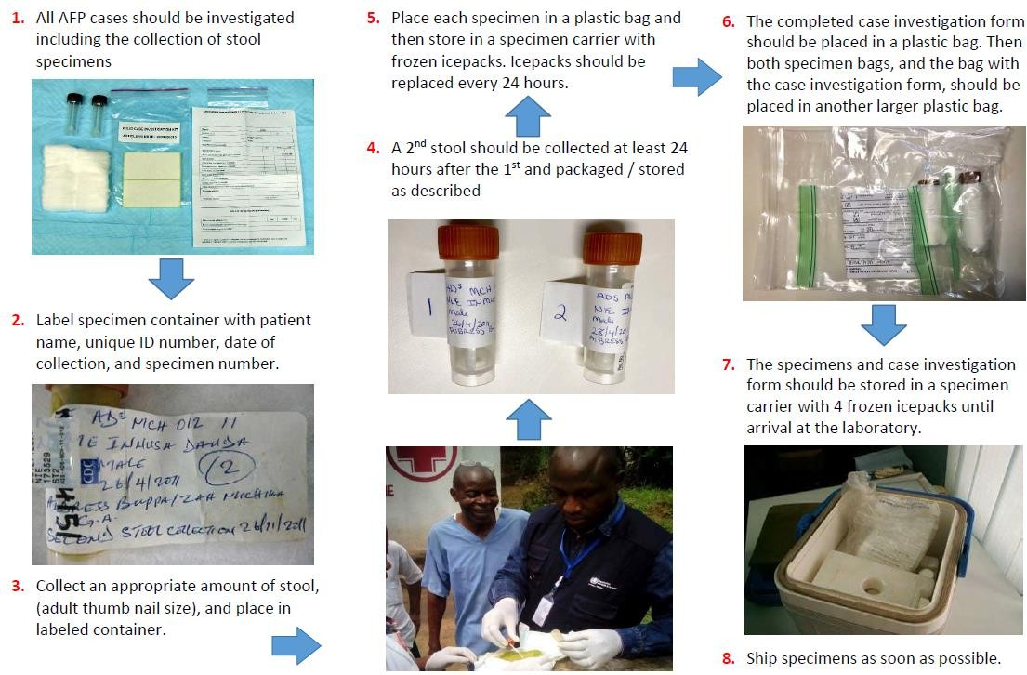

Source: WHO.

*Figure 12: Placement of specimens and supplies in sample carrier, side view*

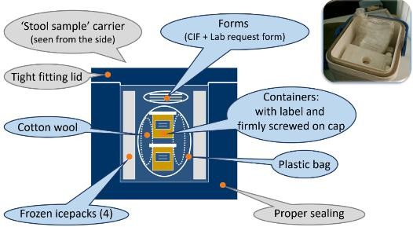

*Source:* WHO.

## Annex 7. Special population groups

###### Table 17: Special population groups

|  |  |
| --- | --- |
| **Special population groups** | |
| **Definition** | Special populations are groups that are not served or are underserved by the regular health delivery system. |
| **Categories** | 1. Populations living in security-compromised areas 2. Mobile populations: nomads and seasonal migrants (e.g., agricultural or mine workers, brick kilns, construction workers, etc.) 3. (a) Refugees and IDPs in camps and (b) those living in host communities 4. Special populations in settled areas (e.g., cross-border population, urban slums, islanders, fishermen, etc.) |
| **Identification & mapping** | It is important to identify and profile these populations based on:   * geographic location, population size, movement routes, timing/seasonality of movement; * access to health services, health-seeking behaviors, ability of the current surveillance network (health facilities, community-based) to detect AFP cases within the group; * identification of service providers (public and private, including NGO’s, faith-based organizations, etc.); * vaccination coverage and immunity status; and * availability of communication activities targeting these special population. |
| **Rationale for special activities to reach particular populations** | These populations may have more susceptibility to the disease and more likelihood of missing and spreading transmission.   * Underserved populations may not be covered by the surveillance system. * There is likely lower population immunity due to low vaccination. * High movement makes them prone to spread the virus to vulnerable populations. |
| **Challenges and anticipated issues for surveillance among special populations** | * Difficulties with mapping and population estimates * Lack of coordination with stakeholders * Lack of community involvement * High cost of resources and logistics: trainings, transportation, supervision, monitoring * Lack of security |
| **Tips for success** | Special population surveillance is facilitated by:   * Special teams dedicated to surveillance in special population * Close coordination with partners (UNHCR, IOM, INGOs, civil society, veterinary services, etc.) |
| **Surveillance strategies applicable to the special population** | 1. **Populations living in security-compromised areas**    * Access mapping and analysis that identifies key partners and factions, population dynamics and changes.    * Access negotiating    * Sensitizing and briefing armed forces, relevant partners and community members about polio and AFP case reporting.    * Revising surveillance network by identifying and training appropriate focal points for case reporting— i.e., community-based surveillance (CBS) as appropriate.    * Conducting periodic active case search in community and healthcare facilities.    * Contact sampling around AFP cases (one sample, three contacts).    * Conducting healthy children stool surveys and ad hoc environmental surveillance (ES), to be decided in coordination with WHO country and regional teams.    * Ensuring access tracking and segregated data analysis to monitor surveillance by   population group. |

|  |  |
| --- | --- |
| **Special population groups (continued)** | |
| **Surveillance strategies applicable to the special population** | 1. **Mobile populations**    * Mapping and profiling with leaders or persons identified as surveillance focal points.    * Determining itineraries of the population and mapping healthcare facilities and providers (including veterinarians) along the route.    * Sensitizing population and providers.    * Conducting market sensitization along the route and close to water points and camps.    * Establishing regular contact with focal points for reminders and feedback on reporting.    * Conducting active case search in large gatherings of nomadic groups during SIAs and mobile outreach services.    * Collecting contact sampling around AFP cases (one sample, three contacts).    * Conducting healthy children stool surveys to be decided in coordination with WHO country and regional teams.   A similar approach will be used for other mobile population groups as appropriate – e.g., seasonal migrants such as agricultural or mine workers, brick kilns, or construction workers. |
| **3a. Refugees/IDPs in camps**   * Identifying focal points in camps (IDP or refugee) to include in the surveillance network. * Profiling new arrivals (origin and immunization status). * Conducting active case search in health facilities of camps and during SIAs. * Collecting contact sampling around AFP cases (one sample, three contacts). * Collecting healthy children sampling (new children under five year), to be decided in coordination with WHO country and regional teams. * Installing a permanent vaccination/surveillance team.   **3b. Informal IDPs and refugees in host community**   * Identifying key informants from the community to include in surveillance network. * Providing appropriate job aids. * Initiating community IDP and refugee tracking (tracker team). * Determining health-seeking behavior. * Adjusting surveillance network. * Conducting active case search during SIAs and mobile activities. * Collecting contact sampling around AFP cases (one sample, three contacts) * Collecting healthy children sampling (health facilities used by IDPs or refugees), to be decided in coordination with WHO country and regional teams. |
| 1. **Special populations in settled areas**   *Cross-border populations*   * + Mapping official and non-official border crossings   + Mapping seasonal movements   + Estimating population flow averages   + Mapping and profiling villages/settlements, special populations, security and access, gathering places on both sides   + Mapping areas of one district/country only accessible from the neighboring district or country   + Mapping of surveillance network on both sides   + Identifying organizations working at border entry and exit points (e.g., immigration, port health services, police)   + Providing orientation and sensitization of populations and healthcare providers on both sides   + Using supplemental strategies   + Active case search on both sides in the community (entry points, permanent vaccination sites, markets) and in health facilities   + If there are security-compromised areas or special populations as refugees or IDPs,   implement the specific proposed activities/strategies |

|  |  |
| --- | --- |
| **Special population groups (continued)** | |
| **Monitoring and Evaluation** | * 4. Special populations in settled areas (continued) * Urban slums * Profiling communities and their origin * Studying health-seeking behavior and modification of surveillance network * Conducting active case search * Consider adding ES sites |
| * Conduct a segregated analysis to ensure surveillance coverage and quality by population groups (starting with appropriate data collection) * Conduct regular mapping and risk assessment * Review/assess implementation of plans * Engagement of partners for independent monitoring |

AFP = acute flaccid paralysis; CBS = community-based surveillance; ES = environmental surveillance; IDP = internally displaced population; INGO = International nongovernmental organization; IOM = International Organization on Migration; NGO = nongovernmental organization; UNHCR = United Nations High Commissioner for Refugees; WHO = World Health Organization